*Got a drone?   
Try this…*

Learning Activities and Science Fair Project Suggestions   
for You and Your Recreational Drone

Maneuvering through a fast-paced video game takes skills—piloting an unmanned aerial vehicle (a drone) in the real world can present an even bigger challenge. Flying a recreational drone pits you against the law of gravity as well as environmental conditions. When you attempt to accomplish some goal with your drone, you use your joystick skills as well as some science and engineering concepts.

Check out the activities in this guide for ideas about what you might learn with your drone. Team up with some helpers or other drone pilots to compete or collaborate on one or more activities. If you set out to learn something, and document your procedures, you could fly your way to a winning science fair project.

Note that this guide is not designed to teach you how to fly your drone… We assume that you’ve already learned the skills you need to safely pilot your drone, and you’re ready to apply those skills in new ways.

**Safety first!**

No matter how experienced you may be, start each flying session with a focus on safety; plan ahead to be certain no one is hurt while participating in drone flights.

**What are these flying things called?**

Recreational drones are “toys” that weigh less than a half-pound. They are also called Unmanned Aerial Vehicles (UAVs), Unmanned Aerial Systems (flight unit plus controller), quadracopters, and other names. Throughout this guide, we use the term drone.

**Table of Contents**

What payload can my drone carry? 2

How fast can my drone fly? 4

How high can my drone fly? 6

A 3d view from a drone 8

Science & Engineering Practices and the Engineering Design Loop 10

Science Project and Science Fair Template 11

Comparing images from satellites and drones 14

Collecting data with drones 15

UAV Challenge: Aerial Survey of a Disaster Area 17

Additional Ideas 28

Acknowledgements 28

**What payload can my drone carry?**

Small sensors that measure environmental conditions such as temperature, air pressure, and location are becoming widely available at reasonable prices. Can your drone carry one or more of these into flight?

The Challenge:

Design and conduct an experiment to find a practical limit on the payload mass your UAV can carry into flight.

Suggested Materials:

String, shoelaces, or rubber bands

Set of metal washers, bolts, or other small weights

Small food or postal scale to measure weights

|  |  |  |  |  |  |
| --- | --- | --- | --- | --- | --- |
|  | Trial 1  UAV only | Trial 2  UAV + Payload | Trial 3  UAV + Payload | Trial 4  UAV + Payload | Trial 5  UAV + Payload |
| Mass |  |  |  |  |  |
| Ability to launch (good, fair, poor, fail) |  |  |  |  |  |
| Ability to maneuver  (good, fair, poor, fail) |  |  |  |  |  |
| Payload mass |  |  |  |  |  |

**Think it through:**

What will you do to collect the information you need?

Questions to consider: Does the sample data table above include all the information I need? Are the terms “good, fair, poor, and fail” sufficient descriptions of my drone’s abilities? Would adding other terms or defining a quantitative scale be helpful?

Have you considered everything you need to take into account to make sure each trial is fair?

Questions to consider: What environmental or drone-based variables that could interfere with your tests. How much error could they introduce into your results? How could you accommodate for those variables so that each trial is a fair comparison of how much weight your drone can carry?

How many separate trials will it take for you to feel confident in your final answer?

Questions to consider: Is one successful trial enough to identify how much weight your drone can carry? Is there a minimum amount of time it has to fly to count? If your drone has the ability to take off with a certain weight, but it has difficulty manuevering, what does that tell you about its practical weight limit?

What kind of graphics, videos, and/or photographs would best document your results?

**Fly your drone to collect data.**

Record data about each session and flight. Use your data to answer the question.

**Present your results.**

You may want to discuss answers to the Questions to Consider as part of your results.

**Follow up**

Search the Internet to find sensors your drone is capable of carrying into flight. Describe experiments you could conduct with one or more sensors and what you could learn from them.

**How fast can my drone fly?**

An afterschool group decided they wanted to make a snapshot of a specific tree on their campus every day. In order to figure out how much time it would take to fly out to the tree, get the picture, and fly back each day, they needed an estimate of the drone’s average forward speed.

The Challenge:

Design and conduct an experiment to find a practical maximum speed your UAV can fly.

Suggested Materials:

Sports field with marked distances

Stopwatches

Several people to serve as timers / spotters

|  |  |  |  |  |  |
| --- | --- | --- | --- | --- | --- |
|  | Trial 1 | Trial 2 | Trial 3 | Trial 4 | Trial 5 |
| Distance |  |  |  |  |  |
| Time |  |  |  |  |  |
| Average Speed |  |  |  |  |  |

**Think it through:**

What will you do to collect the information you need?

Questions to consider: How can I meausure the drone’s average speed over a certain distance without including the time it takes to launch and get up to speed? What minimum distance should the drone cover in each trial to get an accurate estimate of its speed? 5 yards? 50 yards? What did you find was the perfect distance for your testing and why?

Have you considered everything you need to take into account to make sure each trial is fair?

Questions to consider: How can I make sure every trial is consistent? Are all spotters / timers following the exact same procedure? Are spotters’ results the same or close on each trial? What environmental or drone-based variables could interfere with your tests? How much error could those variables introduce into your results? How could you accommodate for those variables so that each trial is a fair comparison of how fast your drone can fly?

How many separate trials will it take for you to feel confident in your final answer?

Questions to consider: What are the practical limits of flying your drone as fast as it can go? At the maximum practical speed you identified, how long would it take for the drone to fly out of the effective range of its controller?

What kind of graphics, videos, and/or photographs would be best to help you document your results? Could you construct a diagram to make what you did so clear that another group could set up the same experiment?

**Fly your drone to perform your experiment.**

Record data about each session and flight. Use your data to answer the question.

**Present your results.**

You may want to discuss answers to the Questions to Consider as part of your results.

**Follow up**

If the tree the group wanted to photograph was located 40 yards from the drone launch site, how much time would it take to get the photograph each day? What other factors should the group consider in estimating the time the daily experiment would take?

**How high can my drone fly?**

If your drone doesn’t have a GPS unit, how can you figure out how high you’re flying?

The Challenge:

Design and perform one or more experiments to help you identify a way to estimate your drone’s height. Use your experience to judge which method provides the most accurate estimates.

Suggested materials

Football or soccer field with marked distances or measuring tape

Angle-measuring app on a smartphone

OR

Protractor inclinometer (find instructions online to make your own)

Scientific calculator

**Suggested Procedure**

Set up a flight zone so the drone pilot and observer are a known distance apart. For instance, you might place yourselves on a sports field so you are 10 yards (30 feet) apart. Record your measurement on a data table.

**Pilot**: Fly the drone straight up and hover directly overhead at the height you want to measure.

**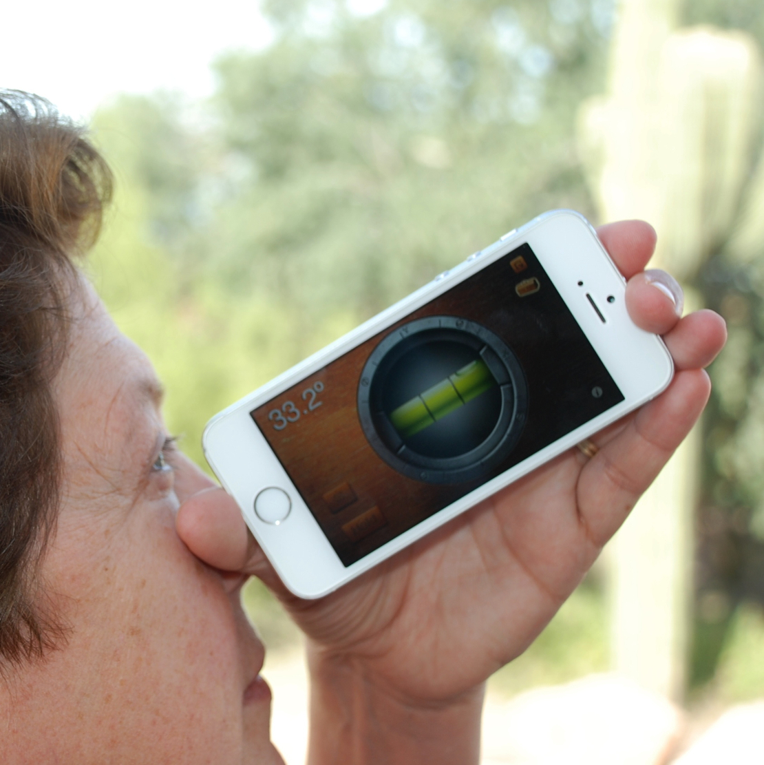Observer**: Use a level app on a smartphone (or a make and use a simple inclinometer) to

1) Measure and record the angle to the drone—you’ll use this value to calculate the height of the drone above your eye level.

2) Measure and record the angle to the spot directly below the drone—you’ll use this value to calculate the height of your eye above the ground.

3) Use the angles and formulas (which use the tangent function (tan) on a scientific calculator) to calculate the height of the drone above the ground.

**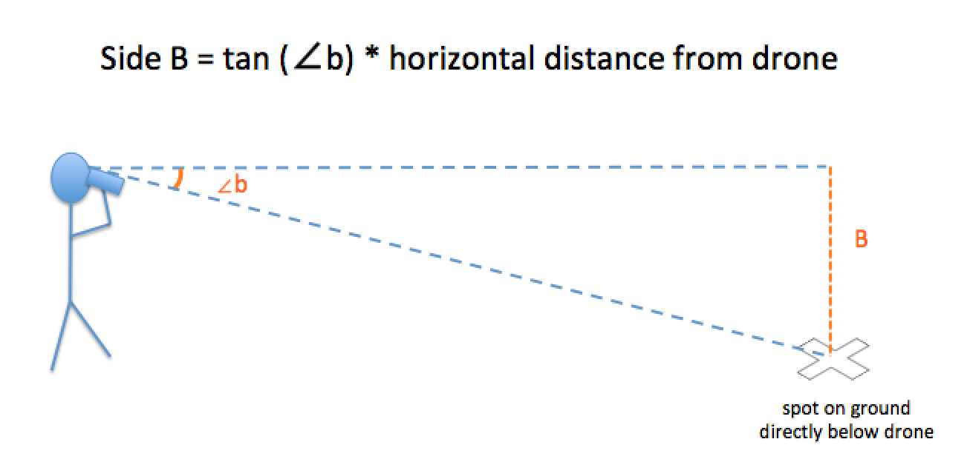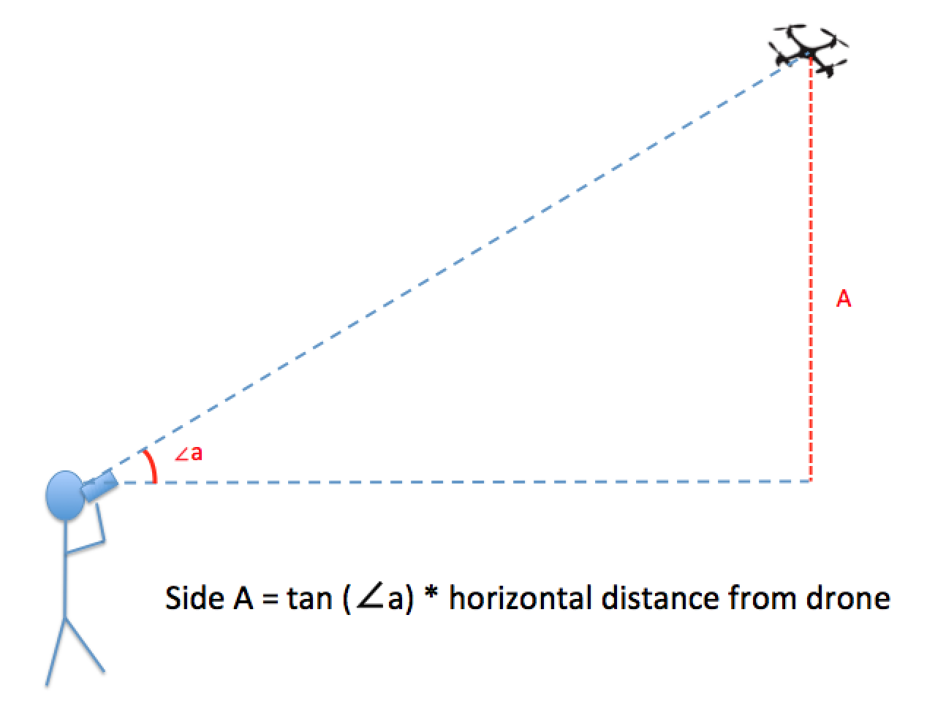**

|  |  |  |  |  |
| --- | --- | --- | --- | --- |
|  | Example | Trial 1 | Trial 2 | Trial 3 |
| Distance from pilot to observer | 30 feet |  |  |  |
| Observed angle to drone | 43° |  |  |  |
| Observed angle to the location directly below the drone | 10° |  |  |  |
| Calculation  (Tan(**∠**a) x distance from pilot to observer) + (Tan(**∠**b) x distance from pilot to observer) =  Drone height above ground | (Tan (33) x 30 feet) + (Tan(12) x 30 feet) = (19.5 feet) + (5.3 feet)  = 24.8 feet |  |  |  |
| Drone Height | 24.8 feet |  |  |  |

**Think it through:**

How many trials will it take for you to feel confident your final answer is accurate?

How might you check if your answer is reasonable?

What can you do with the information of how high your drone is?

How else might you use the technique you used to estimate height?

**Present your results.**

You may want to discuss answers to the Questions to Consider as part of your results.

**A 3d view from a drone**

When walking on a hike or around the schoolyard, sometimes you see something that is high up on a rock outcrop or a wall that catches your interest. Drones can fly up and take photos that you can anlyze later. By planning ahead to have enough overlap between photos, you take take those individial photos and make a   
3-dimensional image!

**The Challenge:**

Design and conduct an experiment to take enough photos to make a 3-dimensional image of an outcrop to study the rocks and view where vegetation is growing on the outcrop.

Steps:

1. Ask questions & define a problem: Pick a question that you want to try answering with your drone.

What can we learn about the rocks where plants are growing on a rock outcrop?

2. Develop & use models: Draw a diagram that shows what you think the rocks and plant roots look like.

3. Create a draft title based on your project question:

Rock, paper, vegetation: An investigation using drones to photograph plant roots breaking rocks

4a. Plan your investigation: Think it through: What are you steps? What will you do to collect the information you need?

Suggested materials:

1. Drone with a camera
2. One-meter circle or square laid on the ground (cloth or tarp)
3. Software that will make a 3D image from photos:
   1. Photosynth: *Capture your world in 3D:* https://photosynth.net - make the 3d image
   2. Autodesk 123D: http://www.123dapp.com/catch
   3. SynthExport: https://synthexport.codeplex.com/ - export tool

Questions to consider as you plan:

What other materials would be useful? What do you plan to photograph?

What order & from what angles will you take the photos? Where: how high, from how far away, how many, how much overlap (>70% if making 3-dimension image)? When during the day, during the year, after an event?

What other data is needed? How does the angle of camera on the drone impact the photos? Are circles still circles in the photograph? What environmental or drone-based variables could interfere with your photographs?

Does the sample data table in step 5 include all the information I need? Who do I need on my team? Who will be the pilot? The photographer? The spotter?

4b. Sketch a map showing planned route for your drone to fly and from which directions. If you are taking photos, where will the photos be taken? Where will the pilot, photographer, and spotters stand?

After the investigation, show locations of your photos.

What other information should be in your sketch? How far from the outcrop will the drone need to fly and get enough detail for your project? How many photos will you need to take to have 70% overlap? What hazards are there to be avoided?

4c. Use Math / Computational Thinking: How you will measure the size of objects and the height of your drone? (Hint: cut a tarp into a circle or square, one-meter across – other methods?)

5. Fly your drone and collect your data. (Carry out your investigation): Add information about your photos in a table. What new questions did you think of while conducting your investigation? Record data about each session and flight.

Consider making a table similar to this for your data:

|  |  |  |  |  |  |
| --- | --- | --- | --- | --- | --- |
| Flight 1: Location identification numbers for map | Name of pilot, photographer, spotters | Range of photo numbers | Date & Time Range | Height above ground, Distance from the outcrop & Area covered of each photo.  Direction of image collection  (Panorama, Walk, Spin, Wall) | Description of image (Are there trees, bushes, grasses at the top of the outcrop? How far do the roots go into the rock? How is the rock where there are roots different than other areas? Color, consistency, staining, etc.) |
| Test circle | Pilot:  Photographer:  Spotters: |  |  |  |  |
| 1 |  |  |  |  |  |
| 2 |  |  |  |  |  |
| 3 |  |  |  |  |  |
| 4 |  |  |  |  |  |
| 5 |  |  |  |  |  |

6a. Analyze & Interpret Data: Use your data to answer the question you asked. Organize the data – How do they contribute to answering your questions?

Using software such as Photosynth or Autodesk 123D, stich the photos together to make a 3D image or panorama.

6b. Use Math / Computational Thinking during your analysis:

Measure the objects in your photos - are circles actually circles? How do the sizes of objects in photos change with distance and height of the drone? Generate statistics from your data. What patterns do you see in the rocks and/or roots? How far or how large an area of the outcrop has plant growth in it?

7. Construct Explanations & Design Solutions: What have you learned from data that help you answer your project questions? How would you have changed your investigation design? Consider adding the answers from the questions to consider in step 4.

What modifications, sensors, and/or instruments would have helped with your project? Take a look at the engineering design loop for ideas.

8. Engage in argument from evidence: What questions might others ask you? How would you respond and how would you use your data and analyses as supporting evidence for your discussion?

9a. Present your results: Communicate: Make a Science Fair Display of your project and results

Compile flight log, hypothesis, images, data chart, conclusion and any additional project pictures and results into a short report (or power point) for a classroom presentation or science fair exhibit.

9b. Communicate & Evaluate: What would you tell your community leaders? Go online – what information would add to your project? What other ways could you use this information? What other data would be useful to evaluate if drones are useful & successful for these types of investigations?

Brainstorm additional projects you can do with the camera on your drone; what other 3D projects could you do; how could printing the 3D image help with your analysis, communication etc.

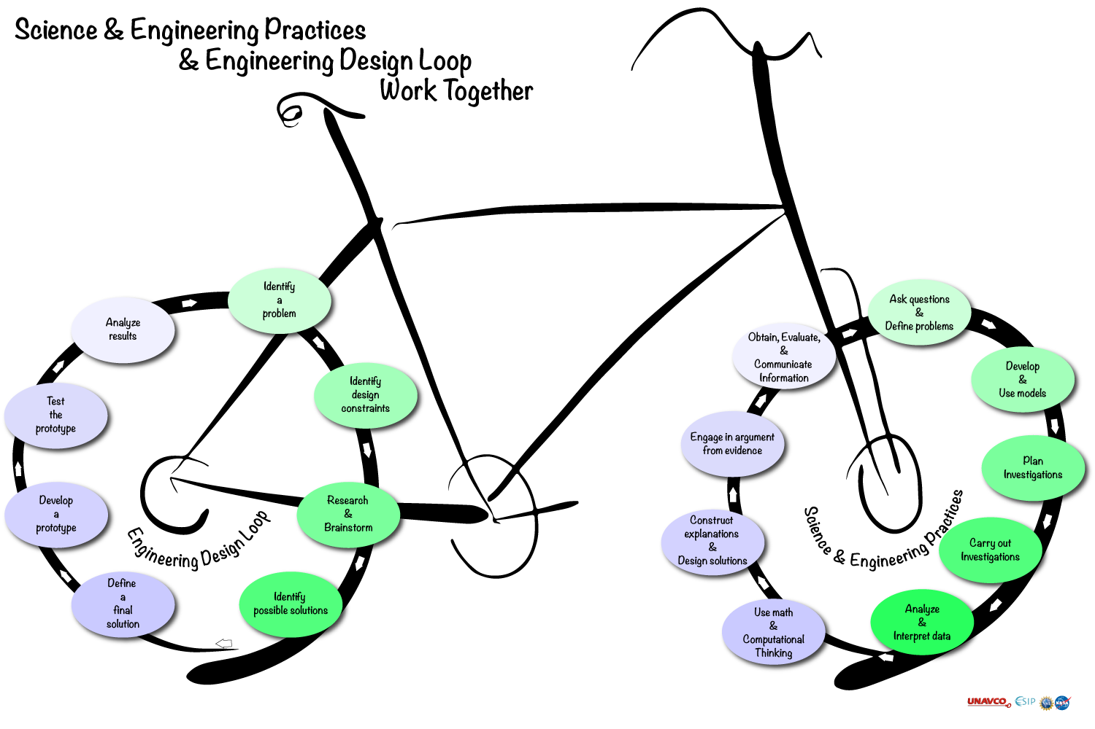

**The Science & Engineering Practices and the Engineering Design Loop Work Together: An example.**

You’ve found the perfect science project to try out! Your question has helped define the problem you want to study, and you are working through the Science & Engineering Practices. As you start putting together a model to describe your hypothesis and plan your project, you realize that you don’t have all of the parts to make the study work. They could be rubber bands and Velcro to hold a tiny instrument to your drone. Maybe you’re working with a team of makers to build your own sensor. Perhaps it’s a better camera that is super lightweight. Maybe you want to change the angle of the camera so that it points straight down or straight ahead.

Either way, your project has taken a turn towards engineering design! Whether it is a small modification or a complete separate project, the Engineering Design loop is a great way to approach to solve a problem. While the loop is drawn in a circle, you might find that you need to do some jumping within the loop around to come up with a working prototype and final design. In fact, often scientists and engineers will go back and forth between the two loops to inform, test, and refine the product being produced and its impact on the scientific study.

Try it out! You might realize that you are already doing both science & engineering in your projects!

1. Ask questions & define a problem:

Pick a question that you want to try answering with your drone

Your Name &

Team members

2. Develop & use models: Draw a diagram that shows what you think you will find.

3. Create a draft project title based on your question:

4b. Sketch a map showing planned route for your drone to fly and from which directions. If you are taking photos, where will the photos be taken?

After the investigation, show locations of your photos.

4a. Plan your investigation:

What are you steps? What will you do to collect the information you need?

4c. Use Math / Computational Thinking:

How you will measure the size of objects and the height of your drone? (Hint: cut a tarp into a circle or square, one-meter across – other methods?)

The Science Project & Science Fair Template Use these science & engineering practices to guide you through an investigation or project.

1

5. Carry out your investigation: Add information about your data in a table. What new questions did you think of while conducting your investigation? Record data about each session and flight. Use your data to answer the question you asked.

6b. Use Math / Computational Thinking during your analysis:

Measure the objects in your photos - are circles actually circles? How do the sizes of objects in photos change?

Generate statistics from your data. What patterns do you see?

6a. Analyze & Interpret Data:

Organize the data – How do they contribute to answering your questions?

7. Construct Explanations & Design Solutions: What have you learned from data that help you answer your project questions? How would you have changed your investigation design?

2

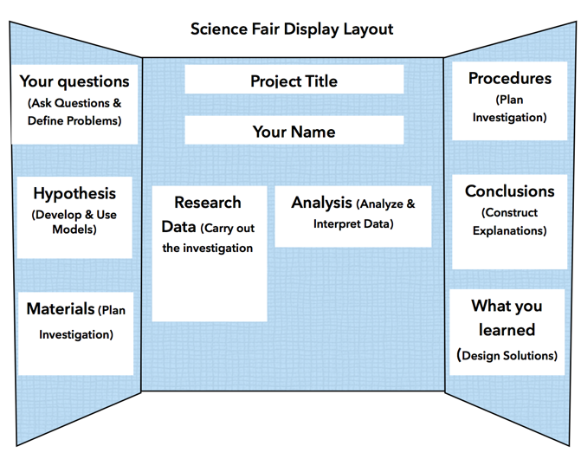

8. Engage in argument from evidence: What questions might others ask you? How would you respond and how would you use your data and analyses as supporting evidence for your discussion?

9a. Communicate: Make a Science Fair Display of your project and results

9b. Communicate & Evaluate: What would you tell your community leaders?

What other data would be useful to evaluate if drones are useful & successful for these types of investigations?

Go online – what information would add to your project? What other ways could you use this information?

3

**Comparing images from Drones with Satellite images**

**Objective**: Explore the basic concepts of remote sensing by comparing data collected by instruments on polar orbiting satellites with pictures and videos collected via cameras on recreational drones.

Materials:

1. Satellite Image of your location
   1. SatCam (free citizen science app for iOS devices) <http://satcam.ssec.wisc.edu/>
   2. MODIS Today (free images via any web browser) <http://ge.ssec.wisc.edu/modis-today/>
2. UAV with camera

Steps:

1. Make a hypothesis about this data comparison, for example:

“The satellite image will cover a greater area than our drone” (YES, of course, but you get the idea)

1. Acquire a satellite image on the same day you plan to fly your drone. Identify as many features as possible (clouds, bodies of water, vegetation types, cities or towns etc…)
2. Conduct a drone flight and collect camera pictures. Identify as many features as possible.
3. Organize your data, here is an example of a table you could create:

|  |  |  |
| --- | --- | --- |
| **Date** | **Satellite Image** | **UAV Photo** |
| **Data Source & time**  (temporal resolution) |  |  |
| **Area Covered**  (include units) |  |  |
| **Smallest feature**  (spatial resolution) |  |  |
| **Largest feature**  (scale) |  |  |

5) Make a conclusion based on your data

6) Brainstorm additional projects you can do comparing drone data with satellite images, for example: green-up or green-down, identifying ice on near-by lakes, investigating fall foliage, etc…

7) Compile flight log, hypothesis, images, data chart, conclusion and any additional project pictures and results into a short report (or power point) for a classroom presentation or science fair exhibit.

**Collecting data with drones**

Objective

To give students experience with how drones can be valuable for collecting scientific data, thereby support their inquiry skills as well as their knowledge of drones, knowledge of sensing instruments, and experience flying drones and collecting data from them.

Course Name: Earth Science

Grade Level(s): 6-12

Lesson Plan:   
Collecting atmospheric data with recreational drones

Goals

Students will make predictions, justify their predictions, design a prediction­testing study that involves flying a drone with a sensor. Then they will analyze their data to see if there predictions were correct and suggest a follow­up study

Estimated duration: Three 45-minute class periods

Measurable objectives

1. Salient prediction and justification

2. Feasible design of investigation

3. Successful drone flight and data collection

4. Appropriate analysis of the data results

5. Design of follow­up study that follows logically from the results

Instructional sequence

Period 1: Prediction Justifications, and Investigation Planning

Period 2: At minimum, one class period, though this phase could stretch out depending on the scope of the investigation

Period 3: Data analysis and follow­up suggestion

Materials: Sensor, plus drone with enough lift to carry the sensor payload

Assessment : Rubric­based scoring on the measurable outcomes.

**Activity: Collecting data**

Introduction

Did you ever wonder how much air changes with altitude? Does it always get colder or moister? Does the pressure always decrease? And, how much do these conditions change? Do the changes vary with the weather, or time of day, or season, with what's on the surface, or with the elevation? Drones are great vehicles for collecting data to study these things.

Directions

1. Make a prediction. For example, "If I launch a drone on a flat grassy surface 20 feet above sea level at noon on the first day of every month for a whole year, I predict that there will always be a decrease in temperature going up 200 feet, but sometimes there will be a bigger difference between the surface temperature and the temperature at 200 feet than at other times.

2. Explain your reasoning behind the prediction. For example, "I predict this because I know that air is thinner the higher you go and so is its retention of radiated heat at the surface."

3. Choose a sensor. Make sure the sensor is designed to be capable of having its data uploaded to a computing device for analysis.

4. Use Velcro or a well tied string to attach the sensor to the drone.

5. Decide how high you want to fly the drone.

6. Make a table to record your data. Make one column for elevation and another for data readings from the sensor.

7. Fly the drone, and note the data readings at equal intervals of change in elevation. For example, if you are flying your drone up to 200 feet, you could take a reading at a height slightly above ground level, then at 50 feet, 100 feet, 150 feet, and 200 feet.

8. Once you have the data, determine if your prediction is correct and try to render a scientific explanation for the results.

9. Present your data and explanation.

10. Suggest what would be a good follow up study with the drone.

UAV Challenge: Aerial Survey of a Disaster Area

**Introduction**

Students will fly their UAVs (Unmanned Aerial Vehicles or "drones") over a scale-model town that has been struck with a disaster, surveying the damage via a camera on the UAV.

This activity can serve as a culminating activity in a series of UAV activities (see links below) that build upon each other. This activity can serve as a performance assessment for the entire sequence of activities, since the challenge presented in this activity incorporates skills and knowledge gained from all the other activities in this series.

We recommend that students complete the [Learn to Fly! UAV Flight School](http://scied.ucar.edu/activity/uav-flight-school" \t "_blank), [Learn to Fly! UAV First Flight](http://scied.ucar.edu/activity/uav-first-flight" \t "_blank) and [Learn to Fly! Aerial Maneuvers with a UAV](http://scied.ucar.edu/activity/uav-aerial-maneuvers" \t "_blank) activities as prerequisites to this activity.

You might also want to have your students experience the [UAV Performance Test: Carry a Payload](http://scied.ucar.edu/activity/uav-test-carry-payload" \t "_blank) activity in preparation for this activity. In the Carry a Payload activity, students determine the maximum weight that their UAVs can lift. In that activity students become familiar with the way additional weight affects the flight performance of their UAV. That familiarity could be handy in this activity, in which the UAV carries the extra weight of a camera.

You might also wish to have your students complete the [UAV Performance Test: Battery Lifetime](http://scied.ucar.edu/activity/uav-test-battery-lifetime" \t "_blank) activity before trying this challenge. That activity will help them estimate how long their UAV can stay airborne, which will help them plan their mission strategy in this challenge.

**Credits**

This activity was created by [Randy Russell](http://scied.ucar.edu/randy-russell" \t "_blank) and John Ristvey of the [UCAR Center for Science Education](http://scied.ucar.edu/" \t "_blank).

**Grade Level**

This activity is best suited for students in middle school or high school. Some upper elementary students might be capable of conducting this activity as well.

**Time Required**

Teacher Preparation Time: 60 minutes to gather materials for the simulated town, set up the town, practice the activity and prep UAVs for student use (charging batteries, etc.).

Class Time: About 90-135 minutes, depending on which options you include and how much time you have students spend on in-depth analysis of aerial images. Depends on how many students can be doing the activity at the same time, which is dependent on the number of students in your class, the number of UAV's available, the amount of materials available to make simulated scale-model towns, the number of adults available to supervise student groups, and the space available for flying.

**Approximate times for the subsections of this activity:**

Explain the Challenge: 20 minutes

Assign Roles to Team Members: 20 minutes

Aerial Photography: 20 minutes

Aerial Survey: 30 minutes

(optional) In-depth image analysis and disaster response planning: 45 minutes

**Learning Goals**

* Students will learn how remote sensing and aerial reconnaissance can be used to help people in disaster situations.
* Students will learn to plan an aerial survey mission to maximize the amount of useful data they can retrieve in a limited amount of time.
* Activity Objectives
* Students will practice interpreting aerial photographs.
* Students will discover the challenges related to capturing and interpreting remote sensing data.
* Student will work as a team, filling various roles (Pilot, Safety Officer, Camera Operator, etc.).

**Lesson Format**: Hands-on activity

**Science Education Standards Addressed**

Next Generation Science Standards

* 3-5-ETS1 Engineering Design
* MS-ETS1 Engineering Design
* HS-ETS1 Engineering Design

**Materials**

For each Student:

* safety goggles

For each Group:

* photo(s) of what the simulated town looked like before the disaster
* items  (tape, rubber bands, pipe cleaners, etc.) for students to use to attach a camera to their UAV in an orientation that allows it to capture images of objects directly beneath the UAV
* one or more UAV ("drone") with a camera and the controller used to fly the UAV
  + **Note:** we used the SYMA X5HW-I. Some of the instructions and images are specific to this particular model, but most aspects of this activity can be done equally well with other UAV models.
* smartphone or tablet computer with software app for displaying the images and video from the UAV's camera
  + **Note:** the SYMA brand UAV that we used while developing this activity includes a software app called SYMA FPV that runs on smartphones or tablets. The app allows you to connect with the UAV's camera during flight, watching the live video feed from the phone or tablet. It also allows you to record the video feed or to take still photos whenever you choose. You will need to download and install the SYMA FPV software onto the smartphone(s) and/or cameras you plan to use with this activity. If you are using a different UAV model, consult your user's guide for information on viewing and recording video and photos with your UAV model.
* extra batteries for the UAV
* stopwatch (optional)

For the Class:

* an open space in which to fly. We recommend flying indoors in a large open space like a gymnasium. Minimally, an area 20x30 feet with a ceiling height of 15 feet should suffice.
* materials for building the simulated, scale-model town. (See Bulding the Town, below.) Items such as toy cars and buildings, Duplo™ and/or Lego™ blocks, small dolls and figurines, water bottles and similar items work well. Avoid items that are too lightweight - the "wind" from the UAV's propellers can blow those around - and items that could break if the UAV lands or crashes onto them.
* materials for building a barrier that blocks the students view of the simulated town; such as a waist-high "mountain range" made by draping a plastic tarp over a few chairs

Preparation

* Conduct a few test flights to determine how easy or difficult this activity will be for students.
* Create a simulated, scale-model town (see description below).
* Charge batteries for the UAV, including spares.
* If your UAV model includes a detachable camera, install the camera on the UAV for this activity.

**Building the "Town"**

Use whatever materials you have readily available to build a simulated, scale-model town. Here are some suggestions for features to include and items to use to represent them:

* **Buildings:**Wooden blocks, boxes of various sizes, and Lego™ or Duplo™ blocks work well for buildings. Use stacks of cans (soda cans, canned green beans, etc.) or Pringles® cans for round towers. Buildings made with pieces or segments, such as blocks or stacks of cans, can readily be converted to "damaged" forms after the "disaster" by placing some of their parts on the ground nearby. Buildings could include houses or apartments, a hospital, fire department, a school, city hall, a church, and so on.
* **Vehicles:** Toy cars, trucks, ambulances and fire trucks, bulldozers help tell the story of the disaster's status. Are there crashed or overturned vehicles? Are there emergency response vehicles on the scene, and if so, where? Is construction equipment digging through rubble?
* **People and Animals:**Dolls, stuffed animals and figurines of all sorts can be used as people, pets, and livestock. Pick a size that strikes a balance between large enough to recognize via the UAV's camera and not too large in proportion to buildings, vehicles, and other features.
* **Water Towers:** Water bottles work well for this, and can readily be overturned to represent damage. Do the town's residents have drinking water or not?
* **Gas or Oil Tanks:** Tanks of petroleum for fuel or heating can represent fire dangers. Metal or plastic bowls, turned upside down, or small balls could represent tanks of gas or oil.
* **Flooding or Lava:** Blue cloth or plastic sheeting can be used to represent water that is flooding portions of the town if you present a flooding or hurricane disaster scenario. Make sure your "water" is secured to the floor so the "wind" from the UAV doesn't blow it around. Red material could represent lava if you choose a volcanic eruption for your disaster.
* **Use your imagination!** If there are landmarks (statues, sculptures, unusual buildings, etc.) in your town or nearby places that you can incorporate to make the town feel more familiar to your students, add those in.

Be aware that lightweight objects might be blown around by the wind from the UAV's propellers; use relatively heavy or dense objects for parts of your town.

You can do a quick check of the ease or difficulty of identifying your model town's features via the UAV's camera by hand carrying the UAV over the town with its camera on. This can help you quickly determine whether certain features are clearly too easy or difficult to identify. Keep in mind that the images from a flying UAV, as compared to a hand-held UAV, may be much less clear and far more difficult to interpret. Pay attention to scale when choosing objects, to make identification via images from the UAV simpler. A doll or figurine representing a person should be smaller than a vehicle; a vehicle should be smaller than a building.

Once your town is assembled, take one or more photos of it in its undamaged state. Provide these "before" images to your students to serve as a map of the town - so they can plan which areas to fly over and photograph - and to compare to their aerial images to assess damage. You can take multiple photos if you want: from "ground level", from above, and from different cardinal directions (North, South, East, West).

After you have photographed the undamaged town, create some damage from a disaster.

* Decide what kind of disaster you want to represent. You may want to choose a disaster appropriate for your region. For example, is your locale prone to earthquakes? Tornadoes? Flooding? Hurricanes?
* If you have buildings made of multiple parts (blocks or stacks of cans), take some of the parts off and place them on the ground nearby.
* Tip over water bottles to represent damaged water tanks.
* Dolls or figurines lying on the ground can represent injured people.
* Overturned vehicles can indicate crashes.
* The presence of emergency vehicles such as ambulances or fire trucks can show where aid is needed.
* You can use blue paper or cloth or plastic sheeting to represent floodwaters... but will need to tape them down or otherwise secure them to prevent the UAV from blowing them around.
* Strips of red crepe paper or plastic can represent fires.

**Building the "Mountains"**

The "mountains" prevent the students from directly viewing the damaged town, requiring them to survey the damage via the UAV's camera. The mountains should be between the place where the Pilot and the rest of the students stand and location of the simulated town. The mountains should be just tall enough to prevent students from seeing the town by peering over the mountains. Don't make the mountains too tall; students should be able to keep their UAV in view at all times while flying, even when the UAV is hovering over the town on the far side of the mountains.

Here's one example of a simple way to make a "mountain range":

* Place a few chairs side-by-side.
* Drape a plastic tarp (about 8 x 10 foot size works well) or one or more bed sheets over the chairs.
* Tuck the ends of the tarp or sheets under the feet of the chairs to prevent them from blowing around when the UAV flies over.

Step-by-step Instructions (for the teacher)

**Explain the Challenge**

* Explain to your students the challenge they are trying to solve in this activity.
  + The nearby town of Disasterville has been struck by a calamity (choose between an earthquake, tornado, flooding, volcanic eruption, hurricane, etc.). Communication with the town has been cut off.
  + Students need to fly their UAV over the town to survey the damage to Disasterville. They will use the camera and video capabilities of the UAV to take photos and/or videos of the town.
  + You might want to devise a fairly in-depth story or lifelike scenario for this challenge, choosing a disaster scenario that is especially relevant to the area where you and your students live. You could base your scenario on actual, historical events. For example, the **[challenge description page](http://scied.ucar.edu/sites/default/files/images/activity/mountainrescuef.pdf" \t "_blank)** from our **[Mountain Rescue activity](http://scied.ucar.edu/activity/mountain-rescue" \t "_blank)** includes an actual, real-life scenario that you could adapt for this activity; flooding in a mountain town in Colorado in 2013.
* Provide students with pre-disaster photos of the town to use for reference. This will help students decide where they need to fly and what specific features they should survey. As an alternative, you could give the students a sketched map of the town's layout and key features.
* Students should plan their reconnaissance flight to make sure they survey as much of the town as possible. They should determine specific goals for their survey plans, such as: check infrastructure such as water and gas tanks, examine each major building in town, locate injured people, see where emergency vehicles have gone, and so forth.
* You might want to put a time-limit on the survey process, to simulate the need for quick decisions and actions often required in emergency response situations. If you do include a time limit, tell your students what that is.
* Explain to students that they will probably need to re-examine photos or videos they record during their flight after their flight has ended. Objects that fleetingly whiz by in live views during the flight can be more closely examined by freezing the video during playback after the flight. This realization may help inform student planning of their survey flight.
* As an optional final stage of this activity, you may want to have students formulate a disaster aid plan for this scenario after they've completed their survey flight. If so, inform the students at the start about that aspect of the challenge.
* Tell students that this is a very difficult challenge. They probably won't be able to get good images of everything in the town. Some images may be quite blurry and hard to interpret. Explain that in the real world, disaster response teams often have to deal with similar difficulties and do the best they can under challenging circumstances. Encourage students to remain positive even if this challenge is more difficult than they expect.

**Assign Roles to Team Members**

* There are several possible roles for students in this activity. Some are essential; other are somewhat optional. In some cases, one student might be able to fill more than one role if you need to keep the student groups small. Otherwise, this is a great team activity that can be best done by a group of students, each filling different roles and effectively communication with each other.
* The **Pilot** uses the hand-held controller to fly the UAV, power up the UAV's propellers in preparation for flight, and power down the propellers after the UAV lands. The Pilot listens to instructions from other team members about where to fly to get the desired aerial images covering all the key features in the town. This activity requires good piloting skills to steer the UAV to the right spots and hover in place while capturing photos and video. The group should choose one of their most skilled pilots to fly the UAV during this challenge.
* The **Photographer** monitors the video feed from the camera on the UAV during the flight. She records video and/or takes photos for later analysis. She communicates with the Pilot, telling the Pilot which direction to move to get better footage of a specific goal and lets the Pilot know when to move on after a particular target has been photographed. The Photographer works closely with the Navigator (described below) to make sure all key targets have been observed.
  + **Note:** the UAV model we used while testing this activity is able to send a live video signal from its camera to a tablet or smartphone for viewing during flight. These instructions are written for a system with similar capabilities. Some UAV cameras record photos and videos during flight, but those images cannot be viewed live during the flight; they must be downloaded and viewed after the UAV has landed. If your system has a photo/video system like that, you will need to modify this activity slightly to accomodate that situation.
* The **Navigator** holds the map or pre-disaster photos of the town. She communicates with the Pilot and the Photographer to help them make sure they fly over and get images of as many key targets in the town as possible. The Navigator should be sure to have a clear understanding of the group's strategy for their flight that the group formulates before they fly their UAV. If you need to have small groups, it may be possible to combine the Navigator's and Photographer's roles.
* An optional **Spotter** can help the Pilot by concentrating on keeping the UAV away from obstacles and alerting the Pilot to immediate dangers. This support can allow the Pilot to focus on the mission of flying over places to be photographed. The Spotter can communicate to the Pilot to take emergency evasive actions if danger arises. The Spotter and Pilot should arrange clear signals that they agree upon before the flight.
* An optional **Timer** can keep track of the flight duration and alert the rest of the team about the passing of time during the mission. This is especially useful if your students have previously completed the **[UAV Performance Test: Battery Lifetime](http://scied.ucar.edu/activity/uav-test-battery-lifetime" \t "_blank)** activity and know about how long the UAV's battery lasts during flight. The Timer can let the rest of the team know to "hurry up" if they have used most of their estimated battery charge before they have completed a majority of their mission. The Timer can alert the group that they should fly their UAV back to base soon when the expected battery duration is almost reached.
* The **Range Safety Officer** (RSO) has three responsibilities; explain these to the students:
  + Make sure all students involved with the flight wear safety goggles.
  + Verify that the launch area and airspace are clear before the flight and signal to the Pilot "all clear" when ready.
  + Alert the Pilot if any safety hazards arise during the flight.
  + If a safety issue occurs, the RSO should instruct the Pilot to land the UAV and stop the propellers by pulling down (towards the Pilot) the left lever on the joystick and holding it down.
* Before flying, the team should discuss where each member will stand during the flight.
  + **None** of the students should be allowed to stand where she can **directly** see Disasterville without viewing it via the UAV's camera. Tell this to the students explicitly.
  + The Photographer and Navigator need to be next to one another and near enough to the Pilor to communicate to her.
  + The Spotter also needs to be near enough to the Pilot to communicate with her. If the Spotter faces the same direction as the Pilot, some commands are simpler ("Go right... do you mean **my** right or **your** right?").

**Aerial Photography**

* This activity can serve as an introduction to aerial photography and videography from a UAV. You may decide that photography from a UAV is itself sufficiently challenging for your students that you would like them to gain experience with that skill before attempting this activity. If so, you could have them conduct a relatively quick exercise in which they take a photo or video of some object to prepare for this activity. That exercise can help them discover the quality they should expect to achieve in their aerial photos and videos, how easy or hard it is to point the camera accurately at and object, how easy or hard it is to keep a UAV steady while taking pictures, and so on.
  + A fun variant of this is to have your students take a "dronie" of themselves - a "selfie" photo taken from the UAV (drone + selfie = dronie). This can present a significant challenge in the form of a seemingly simple task. Flying a UAV that is facing towards the Pilot is tricky, since "move left" and "move right" are reversed. Taking a still photo at just the right time is not easy. Pointing the UAV and its camera in just the right direction so the students are all in the frame of the camera is also challenging.
* The UAV model that we used while testing this activity has a camera that is mounted facing horizontally. In other words, it "looks" forward from the front of the UAV. This is not an ideal alignment for taking photos of objects directly beneath the UAV, which is needed in this activity. In testing this activity, we used some tape to attach the camera to the UAV in a non-standard position so it was facing downward. To do so, we had to make sure the camera was still firmly attached, was not interfering with the UAV's propellers, and was still close enough to the socket on the UAV where the wire from the camera plugs in. Also, our downward-pointing mounting left the camera somewhat off-center, which caused the UAV to be somewhat more difficult for the Pilot to control. You might want your students to complete the **[UAV Performance Test: Carry a Payload](http://scied.ucar.edu/activity/uav-test-carry-payload" \t "_blank)** activity before attempting this challenge; it will give them experience flying the UAV when it is a bit more challenging to control due to the added weight. You can have your students take on the challenge of how to best mount the camera in a downward-pointing orientation, posing it as an engineering design challenge that is part of this overall challenge. Your students might invent a creative solution to this problem, such as mounting a small mirror in front of the camera at a 45 degree angle to effectively make it "look" downward.

**Aerial Survey**

1. Place a battery inside a UAV, connect the UAV wire to the battery wire, close the battery compartment.
2. The teacher and the Range Safety Officer should inspect the UAV and the camera mounting for safety.
3. Place the UAV inside of and near one edge of the space you have available for flying.
4. Provide the Pilot with the UAV controller.
5. When it is safe to fly, have the Range Safety Officer indicate to the Pilot that she can take off.
6. The Pilot should control the UAV to take off and fly across the Flight Area, over the simulated mountains, and hover above the simulated town (henceforth referred to as "Disasterville"). The (optional) Timer should start the stopwatch when the UAV takes off and should monitor the elapsed time throughout the flight.
7. The Navigator and the Photographer should advise the Pilot where to steer to bring key landmarks in Disasterville into the camera's field of view.
8. The Photographer should take photos of key features as they come into view and/or record video throughout the flight.
9. If you include the optional Spotter role, that student should advise the Pilot if/when the UAV is drifting away from the safe area to fly or getting too close to any obstacles (such as the simulated mountains). This support from the Spotter can allow the Pilot to focus more fully on following instructions from the Navigator and Photographer throughout most of the flight.
10. The Pilot should fly the UAV back to the takeoff location and land it gently once:
    1. The Navigator and Photographer decide that all of the key features of Disasterville have been photographed or captured on video, or
    2. The UAV's battery gets low, either as indicated by flashing lights on the UAV or when the Timer indicates that the battery is due to run out
11. After the flight, all students on the team should review the photos and/or videos from the flight and assess the state of affairs in Disasterville and determine the extent and type of damage to the town. They should report their findings to the teacher.

There are several optional extensions to this activity that you can have your students try if you have enough time. Details of those options are described in the **Background & Extensions** section (tab) of this activity writeup. Those options include: formulating a disaster aid plan for the town based on their reconnaissance images, making multiple survey flights with analysis and next-flight planning sessions between, conducting this activity as a whole-class, large group exercise, or adding a very challenging task of dropping off supplies into or carrying something out of the stricken town.

Assessment

There are several times during this activity when you can assess students performance. These are mostly natural consequences... proper actions by the students result in successful flights, while inappropriate behaviors are likely to result in poor flights. You can use **[this in-depth assessment rubric](http://scied.ucar.edu/sites/default/files/images/activity/%3Cem%3EEdit%20Activity%3C/em%3E%20UAV%20Challenge%3A%20Aerial%20Survey%20of%20a%20Disaster%20Area/uav_challenge_survey_disaster_rubric.pdf" \t "_blank)** or refer to the bullet points below to evaluate student performance.

* Have the students mounted their camera on the UAV in a way that allows them to capture good pictures? Is the mounting safe, unlikely to interfere with the propellers, and unlikely to fall off during flight?
* Do the students have a good plan for photographing key features in Disasterville?
* Do the Pilot, Navigator, and Photographer have a good plan to communicate with each other during their flight? Do they communicate well during the survey flight? Likewise for the Spotter and Timer if you include those roles.
* Do students successfully capture images of most of the key features in Disasterville?
* How well do the students interpret their data (photos and videos) and accurately assess damage to the town?
* How good is the students' plan for their recommended emergency response to the town? Do they have a good sense of supplies to send? Of the scope of the damage? Of the number of injured people? Of urgent issues to address (destroyed water tower or fire hazard from petroleum tanks)?
* Do students successfully fly their UAV to the town and back and land safely? Do they crash and lose the UAV somewhere near the town? Do they crash their UAV onto anything in the town?

Teaching Tips

**Safety**

* Avoid wind (we recommend flying in a large indoor open space such as a school cafeteria or gymnasium)
* Before flying indoors, check the space you plan to use for safety. Are there any **light fixtures**, **A/V equipment** or other sensitive objects suspended from the ceiling that could be damaged if the UAV collided with them? Are there any **fire sprinkler heads** that might be set off if disturbed by the UAV, flooding the room? Carefully inspect the space for hazards and fragile objects that could be damaged by the UAV. A gymnasium can be a good choice for indoor flying since the fixtures in a gym are generally designed to withstand being hit by objects heavier than a small UAV, such as basketballs.
* Before each flight, check to make sure the student Pilot knows how to quickly land the UAV and how to quickly stop the UAV's propellers. In the event of a crash, sometimes the propellers will continue to spin (if the UAV is leaning against a wall or is upside down) until the Pilot turns off the propellers. In the case of the SYMA UAV model we used while developing this activity, the Pilot must **pull the left joystick towards herself** and **hold it for a couple of seconds** until the UAV propellers stop. Check the instructions for your UAV to make sure you know your model works. Students can become a bit flustered when a UAV crashes, so it is a good idea to review this "emergency" shut down procedure immediately before each flight.
* Whenever a student who is inexperienced at Piloting is controlling the UAV, it is important for the teacher to be near the Pilot and offer assistance as necessary during the flight. In the event of an unsafe situation, help the student in need or take control from the Pilot to ensure that everyone is safe
* Practice at low altitudes
* Set and observe flights in safe places with boundaries clear of hazards
* Be alert. Don't let enthusiasm overcome common sense
* If there is a potential danger, stop and change the situation

Optional Extensions

* As a followup to the damage assessment report, have students formulate a disaster aid plan to help the town
  + Is emergency medical assistance needed for injured people? How many injured townsfolk did the students spot?
  + Is there a need for emergency shelter? Were many buildings damaged? How severely?
  + Were the water tanks or the petroleum storage tanks damaged? Do the townsfolk need supplies of fresh water? Is there a danger of the petroleum tanks ingniting?
  + If possible, what if any aid supplies should be flown to the town? If possible, should any injured people be airlifted out of the town?
* Depending on the time you have for this activity, you might allow students to conduct more than one reconnaisance flight. After they review their photos and videos, they may discover that they didn't get images of certain features of that some of their images are of poor quality. Their second (and subsequent?) flight could focus on getting better images of items they missed. We strongly recommend you allow students more than one flight if time permits; it can be very difficult to get good images on a first flight and frustrating to try to interpret poor images.
* This can also be a whole-class activity. The first team to survey Disasterville could describe their discoveries to the other groups; then different groups could focus on capturing images of areas the first group missed, or that require a second look from another angle or a better quality image. This approach requires a lot of communication and between-group cooperation.
* You could also have students attempt to either deliver simulated aid supplies to the town via a drop-off from a UAV or to airlift an injured person out of Disasterville. This would be a VERY challenging extension to this activity. If you choose this option, it would probably be good for students to complete the **[UAV Challenge: Retrieve a Payload](http://scied.ucar.edu/activity/uav-challenge-retrieve-payload" \t "_blank)** activity before taking on this challenge.

More UAV Activities

* [Learn to Fly! UAV Flight School](http://scied.ucar.edu/activity/uav-flight-school" \t "_blank)
* [Learn to Fly! UAV First Flight](http://scied.ucar.edu/activity/uav-first-flight" \t "_blank)
* [Learn to Fly! Aerial Maneuvers with a UAV](http://scied.ucar.edu/activity/uav-aerial-maneuvers" \t "_blank)
* [UAV Performance Test: Battery Lifetime](http://scied.ucar.edu/activity/uav-test-battery-lifetime" \t "_blank)
* [UAV Performance Test: Carry a Payload](http://scied.ucar.edu/activity/uav-test-carry-payload" \t "_blank)
* [UAV Challenge: Retrieve a Payload](http://scied.ucar.edu/activity/uav-challenge-retrieve-payload" \t "_blank)

**Additional Ideas**

Use your drone to check out something that isn’t readily visible. (Set up a type of scavenger hunt where you ask things like “what object is on the roof?” or “submit a picture of an island in a pond.”

Take pictures of the same thing from two different points of view. Identify similarities in the picture to align them. Use image-processing software to generate a red/blue composite image. View it with red/blue glasses for a three-dimensional visualization.

How does temperature affect battery life/flying time? Can you fly longer in cold or warm temperatures? At high or low elevations? What other factors might affect the maximum flight duration?

What is the maximum distance (range) at which you can control your UAV? Can your UAV receive signals through wood? brick? glass? metal?

Devise a test to find out which materials (or what distance) interfere with the signal from your controller to your UAV. Consider conducting similar tests with other remote devices (Bluetooth computer mouse, cordless telephone, other RC toys)

Take several photos with your drone and use software to “stitch” them together to produce a photo-realistic map of a park or school campus.

How often might you need to update the map to ensure that it remains up to date?

Would it remain the same in each season?

Set up a challenge: Model the steps it would take to deliver food, water, and medical supplies to an area where a disaster occurred. Take a payload of a minimum weight to a specified location, deliver it, and fly the drone back to you.

Explore social facets of using drones. Some people are against the use of drones for various reasons (their use in war, potential for invasion of privacy, the nuisance of noise)

Choose a location and take repeat photography to document change.

Pre-requisite: Figure out how to fly your UAV to the same height and location on multiple occasions for time series photos. Consider using GLOBE and/or Nature’s Notebook protocols to become familiar with observable changes in plants and animals in different seasons. How would you modify the protocols to make observations with your recreational drone?

**Acknowledgements**

These draft activities were contributed by volunteers who participate in the Education Committee of the ESIP (Earth Science Information Partners) Federation. Thanks to LuAnn Dahlman, Collabralink, Inc./NOAA Climate Program Office; Margaret Mooney, CIMSS/UW-Madison; Shelley Olds, UNAVCO; Randy Russell, UCAR Center for Science Education, and Dan Zalles, SRI.