Data to Decisions for Climate Resilience

Introduction. “Data to Decisions for Climate Resilience” comprises a group of individuals (henceforth: “Group”) who shall collaboratively build openly web-accessible concept maps for climate adaptation. These concept maps benefit those who seek to better understand how data may be transformed into information along the data-to-decisions pipeline for climate resilience planning.

Charter. See next page.

Incorporation. The Group is incorporated as an Earth Science Information Partners (ESIP) cluster and as a US Global Change Research Program (USGCRP) NCAnet Affinity Group.

Logistics. Four to five web-facilitated meetings spaced regularly apart will be organized under a theme. A complete “run” of those meetings will result in a small number of interconnected concept maps that relate to the theme covering issues on science, technology, and policy. Concept maps are edited using the freely available CMAP software and hosted on the CMAP cloud. An initial test “run” shall be conducted under the theme of “Indigenous Peoples” based on Chapter 12 of the US Global Change Research Program’s (USGCRP) Third National Climate Assessment (NCA) on “Indigenous Peoples, Land, and Resources”. The first run shall commence on 2017-10-04 (Wednesday) and terminate on 2017-11-29, with each meeting spaced two weeks apart. Each meeting shall commence at 1300 hrs Eastern time for approximately 60 minutes. In-person attendance is available at the USGCRP in Washington DC, and remote participation shall be available over the web.

A subsequent run (if any) shall not be executed until February 2018, leaving time for an evaluation and adjustment of the approach, and organization of a run under a different theme. The Charter for this group expires end of 2017. The Charter, with possible amendments, shall require renewal if subsequent runs are to be conducted.

Overview of first run. Oct 4 (review of Charter and goals of Group, logistics for upcoming meetings); Oct 18 (overview of US statutes, federal policy, decision-making); Nov 1 (NCA chapter 12, Tulalip Tribes on Climate Resilience Toolkit); Nov 15 (indicators, tools, and the Tribal Lands Collaboratory); Nov 29 (National Phenology Network and US climate data); Dec 6 (special session one week after Nov 29 meeting: recap of all sessions via a review of the completed concept maps, post-mortem).

Chair. Brian Wee (orcid.org/0000-0002-0038-9381), bwee@neptuneinc.org

Co-Chair: TBD

Website: TBD

Charter for “Data to Decisions for Climate Resilience”

Author: Brian Wee (orcid.org/0000-0002-0038-9381), bwee@neptuneinc.org
Dated: 2017-09-22
Sunset provision: This charter expires 2017-12-31, unless explicitly renewed.

Objective. “Data to Decisions for Climate Resilience” comprises a group of individuals (henceforth: “Group”) who shall collaboratively build openly web-accessible concept maps for climate adaptation. These concept maps benefit those who seek to better understand how data may be transformed into information along the data-to-decisions pipeline for climate resilience planning. That pipeline, depicted below, is the collective metaphor for each of our respective roles in transforming socio-environmental data into information and knowledge for science, education, and resource-management.

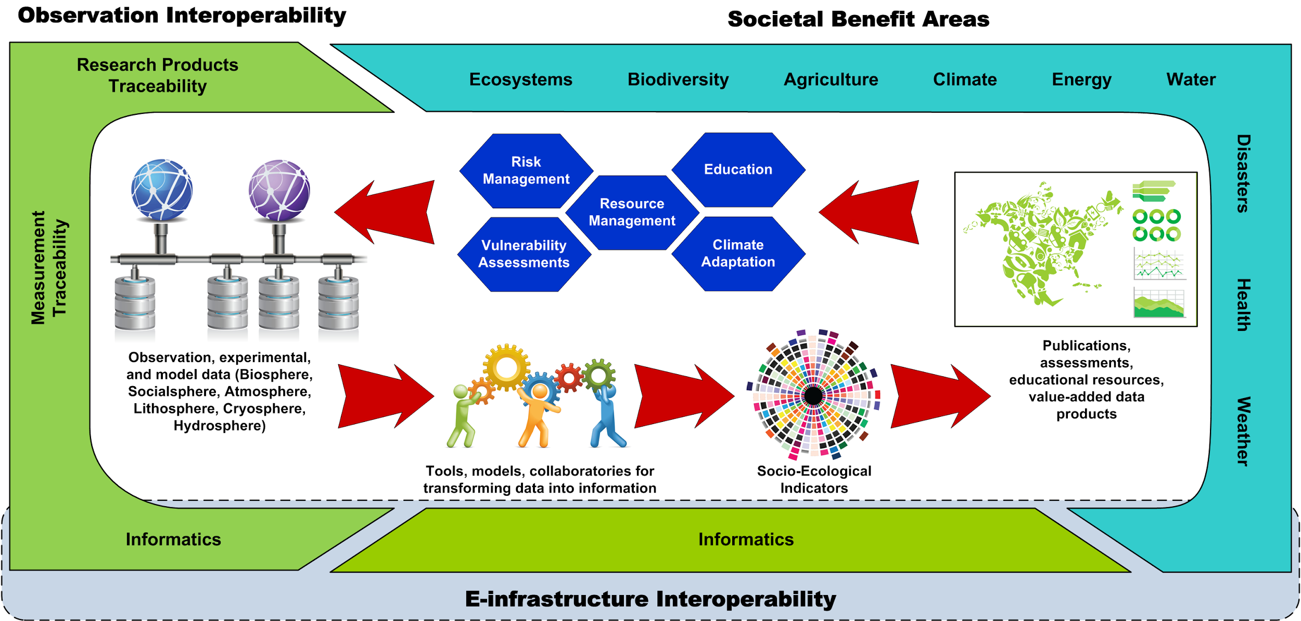
Wee, Brian (2015): Transformation of Data for Societal Benefits. Figshare. https://doi.org/10.6084/m9.figshare.1287369.v3

Motivation. Individuals in the climate change adaptation arena often adopt roles that map onto a specific place along the data-to-decisions pipeline. We are often not aware of the many roles that others play in earlier stages of the pipeline. It is also beneficial for one to know the beneficiaries of one’s work as data and information are incorporated into decisions further down the pipeline. Pipeline “throughput” -- the rate at which we effectively implement cohesive climate resilience solutions -- may benefit from a community that has a better understanding of “the big picture”.

Audience. The intended audience includes:
- Scientists and data management professionals who wish to know how their data may be ultimately be used and potential impact on decisions;
- Informatics professionals who may benefit from gaining an awareness of how their tools are used for science, education, and resource-management;
- Policy professionals who desire to acquire background knowledge of the science and technology that enable adaptation planning.

Concept of operations. Four or five meetings, spaced weeks apart, shall be unified under a theme. The theme should preferably based on a specific component of a USGCRP knowledge product like an NCA3 chapter. Each “run” of the theme starts with a “concept window” focused on the “decisions” end of the pipeline. The window gradually moves towards the “data” end of the pipeline. Science, technology, and policy issues will be given appropriate coverage depending on the placement of the window. A single “run” is considered complete once the window reached the “data” end of the pipeline. At each meeting, the window pauses on a spot in the pipeline, and the Group meets to:
- Preview the scope of the window via a pre-populated high-level concept map,
- Interact with an invited speaker who presents on the issues within the window,
- Provide feedback on how to augment the high-level concept map.
At the end of each “run” through a theme, the Group would have produced a set of connected concept maps covering the data-to-decisions pipeline will that:
- Incorporates the highlights of invited speakers, and
- Points to credible sources of information, like the NCA, the US Climate Resilience Toolkit, the Climate Adaptation Knowledge Exchange, and others.
A theme is then selected for the next “run” of meetings, and the process repeats.

Primary sources of credible data and information. Concept maps shall be edited to allow the broad intended audience to quickly assess the landscape of issues. Should individuals require additional details, nodes in the concept maps shall direct the reader to credible sources of data and information, including government (federal, state, tribal, local) repositories and websites like the USGCRP, US Climate Resilience Toolkit, the Climate Adaptation Knowledge Exchange, and many others.

Vision. If successful, this process may be extended by loosely coordinating groups that each adopt their respective themes. Some level of curation may be necessary to achieve a level of coherence across the collection of concept maps.

Known Challenges. Drawing from lessons learned in the conduct of open science, the following concerns cannot be addressed without dedicated resources given the voluntary nature of participation in this group. These concerns do not prevent the Group from executing its activities. All the same, the concerns should be highlighted so that participants are aware of certain limitations, including: (1) the inability to easily attribute authorship to any given concept map; (2) challenges with versioning concept maps in a consistent manner consistent with, for example, GitHub; (3) assigning a persistent identifier for citation purposes; (4) the inherent difficulties with inconsistencies that will arise across concept maps; (5) the inability to track usage metrics of such maps; (6) the likely limited deployment of APIs for harvesting the maps for further integration; (7) likely limitations in discovery services for maps; (8) usability concerns about editing concept maps using CMAP; (9) and many other concerns that limit the proposed approach from scaling effectively.

