The National Ambient Air Monitoring Strategy: Rethinking the Role of National Networks

Richard D. Scheffe, Tim Hanley, Rudy Husar, Mike Gilroy, Michael Rizzo, Richard Valentinetti, Mike Koerber, Mark Schmidt, Phil Lorang, Paul Solomon, Lew Weinstock, Kevin Cavender, Nealson Watkins, Richard Haeuber, Michael Papp and Joann Rice

INTRODUCTION AND RATIONALE

Numerous revisions to the monitoring regulations guiding national network operations conducted by State and local agencies and Tribes accompanied the 2006 promulgation of the new fine particle standards (EPA, 2006a). In addition to updates addressing a reduced daily PM_{2.5} standard (from 65 to 35 µg/m³, the revised monitoring rule (EPA, 2006b) codified key components of the National Ambient Air Monitoring Strategy (NAAMS; EPA, 2005) that had been under development since 2000. The strategy in large part was driven by a confluence of budgetary pressures and interest from the scientific community stemming from the 1999 deployment of a massive PM_{2.5} monitoring network, as required in the 1997 PM standard revisions (EPA, 1997). Implementation and operational costs for the PM_{2.5} network, which have averaged about $50M annually, raised questions regarding the capacity of the nation’s monitoring infrastructure to incur continued layering of responsibilities as new air quality standards and needs emerge. Coincident with this implementation was a renewed interest in our “routine” networks as a critical research tool for various scientific disciplines; health effects, exposure, atmospheric science, conveyed in a series of National Academy of Science Reports tasked with assessing EPA’s particulate matter research program (NRC, 1998, 1999, 2001). Consequently, our networks were faced with competing needs to be more responsive to scientific needs while working within a so called “zero sum” resource constraint.

A National Monitoring Steering Committee (NMSC), with representatives from EPA and State and local agencies and Tribes guided development of the strategy which was subject to scientific review from 2002-2005 through the monitoring subcommittee of the Clean Air Scientific Advisory Committee (CASAC). CASAC endorsed strongly the themes and recommendations embodied in the strategy. This paper provides an overview of the NMSC.

Rationale for a Strategy.

Ambient monitoring systems are a critical part of the Nation’s air program infrastructure.
Data from these systems are used to characterize “air quality” and associate consequent health and ecosystem impacts, develop emission strategies to reduce adverse impacts, and account for
progress over time. The United States spends well over $200 million annually on routine
ambient air monitoring programs, a figure dwarfed by the billions associated with emission
reduction strategies. Ambient data provide a basis for accounting of air program progress
thereby determining the value of those investments. Obviously, the investment in and role
played by our networks demand periodic strategic planning. Dramatic and mostly positive changes in air quality have been observed over the last two decades, despite increasing population, energy production, vehicle usage, and productivity. Most criteria pollutant measurements read well below national standards (Figure 1). While the more obvious problems of widespread elevated lead and gaseous criteria pollutant problems largely have been solved, current and future problems in particulate matter, ozone, and air toxics challenge air programs. These challenges reside in very complex air pollution behavior (e.g., nonlinear relationships between emission sources and atmospheric concentrations) with increasing knowledge that very low, and difficult to measure, air pollution levels are associated with adverse environmental and human welfare effects. New directions in air monitoring are needed to reflect the successful progress in reducing air pollution and incorporate new scientific findings and technologies. Ambient air measurements produced by State and Local agencies and Tribes (SLTs) are high quality, credible environmental data that service a broad spectrum of clients. The challenge is to maintain and improve upon a valued product in an environment where monitoring programs are subject to changes in SLT, Federal and research priorities. New and revised national ambient air quality standards NAAQS), changing air quality (e.g., significantly reduced concentrations of criteria pollutants) and an influx of scientific findings and technological advancements challenge the response capability of the Nation’s networks. The single-pollutant measurement approach, commonly administered in networks, is not an optimal design for integrated air quality management approaches that can be optimized by accounting for numerous programmatic and technical linkages across ozone, fine particulate matter, regional haze, air toxics, and related multi-media interactions (e.g., atmospheric deposition). Indeed, the current design of the Nation’s networks is based largely on the existing monitoring regulations (Code of Federal Regulations [CFR], Parts 53 and 58) that were developed in the late 1970's. Complicating a desire to implement change is the need to retain stability in ambient air networks for the detection of long term air pollution trends.

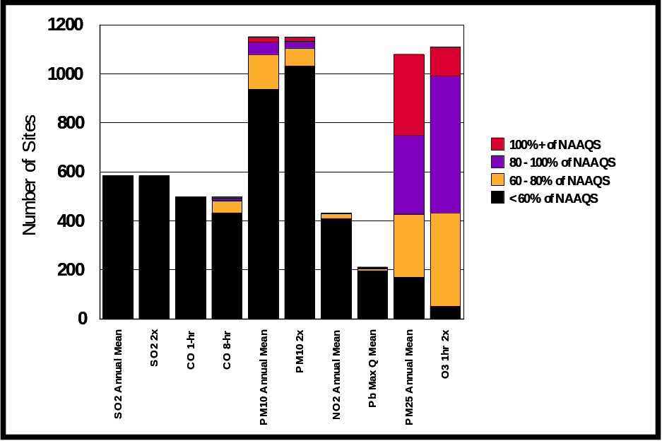
Figure 1. Frequency of measurements relative to the standard for gaseous and particulate matter criteria pollutants.

The strategy is built on five components (Figure 2) addressing network assessments, design, quality assurance, rule development, and technology which collectively are intended to facilitate long term network modifications. This article will review three key areas underlying design, assessment, and technology.
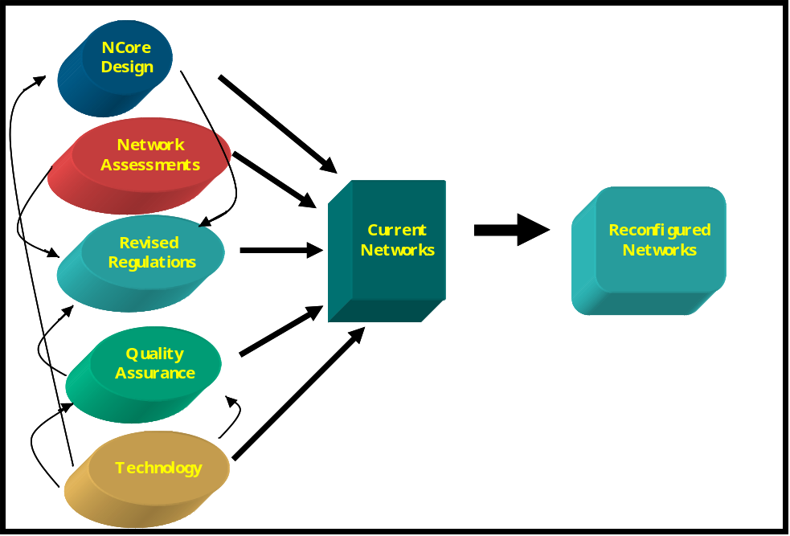
Figure 2. Major components of the National Ambient Air Monitoring Strategy.

Shifting network design: the NCore Monitoring Network
The new national network, NCore, is an extension of the current air monitoring
Networks intended to address new directions in air monitoring, and to begin
filling measurement and technological gaps that have accumulated over the years. NCore originally was conceived as a three-tiered network (Figure 3) with graduated levels of measurement complexity:

Level 1. Sustained research grade stations (3-10 locations) to facilitate technology transfer between research and operational communities, analogous to the PM_{2.5} Supersites program;

Level 2: Multiple pollutant stations (approximately 75 nationally) in most major cities and important transport corridors and background locations intended to capture urban and regional scale representative concentrations; and,

Level 3: a majority of the single pollutant PM_{2.5} and ozone sites used primarily for NAAQS compliance and AQI reporting, but also to complement the limited number of Level 2 locations with added spatial resolution for the most important, regionally dispersed criteria pollutants.
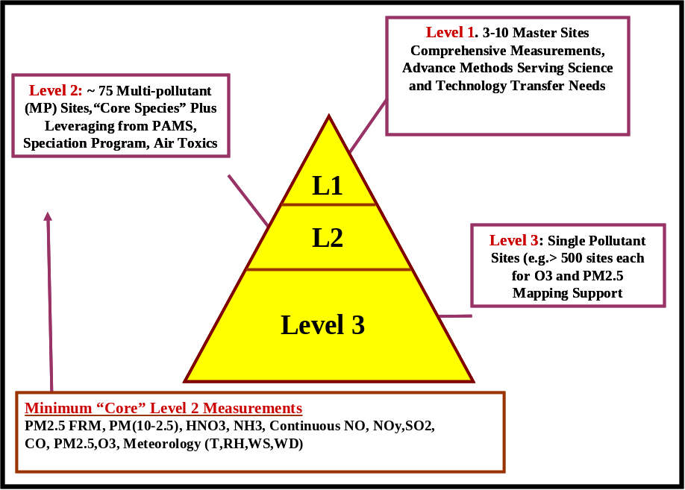
Figure 3. Graded site levels of originally proposed NCore configuration.

The final monitoring rule adopted most of the original Level 2 recommendations under the new NCore program, reflecting an inability to fund Level 1 sites and recognizing that inclusion of Level 3 sites as part of NCore might impair monitoring program flexibility of States and local agencies. These new level 2 sites require a “core” group of measurements that include “trace” gas measurements of carbon dioxide (CO), sulfur dioxide (SO₂) and reactive nitrogen (NOy). The term “trace” is used to emphasize the intention for broad spatial scale representative sampling to capture characteristic pollutant concentrations, often in the low ppb range, indicative of broad population exposures and more consistent with volume averaged estimates (typically > 100 km³ ) produced by gridded air quality models. Coarse particle (PM_{10-2.5}) mass and chemical speciation measurements would be conducted at all NCore locations to develop an information base to support future reviews particulate matter air quality standard reviews. Gaseous ammonia (NH₃) and true nitrogen dioxide (NO₂) are intended to become NCore parameters, pending development and/or agreement of appropriate technologies. Nitrogen dioxide plays an important role in gas phase atmospheric chemistry processes (Figure 4)and consequently is a key parameter for diagnosing air quality model behavior. Ammonia is a ubiquitous compound that participates in secondary particle formation and is a major component of nitrogen cycling between air and surface/water media (Figure 4). In addition to these “core” measurements, the NCore sites would leverage existing PM_{2.5} speciation, Photochemical Assessment Measurement (PAMs) and National Air Toxics Trend (NATTS) platforms offering, in limited, locations an extensive suite of collocated gaseous and aerosol measurements (Figure 5).
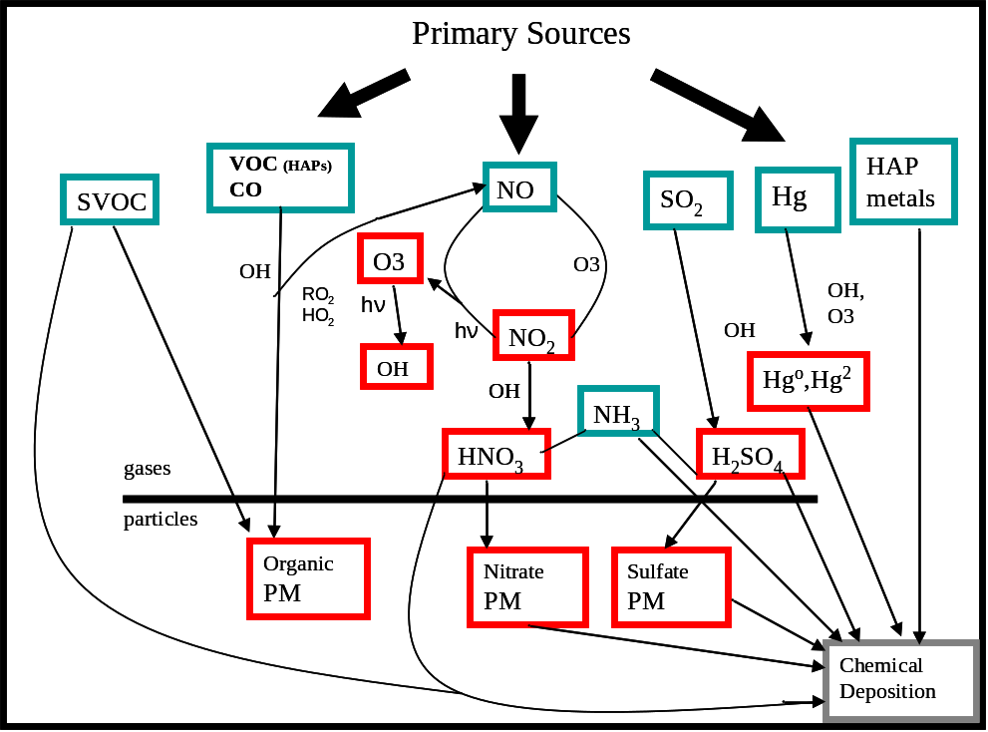
Figure 4. Chemical links illustrating relationships across, criteria pollutants and HAPs including mercury, as well as connections across sources, secondarily formed species, gases, particulate matter and deposition. Primary emissions (green) are distinguished from secondarily formed species (red). Note that this diagram is a highly condensed model that does not capture numerous various heterogeneous processes and complex chemical pathways. Key atmospheric species that are involved in many reactions across pollutant categories include ozone and the hydroxyl radical, OH. Primary PM emissions are not included as they interact marginally with other other atmospheric species (adopted from NARSTO, 2002).
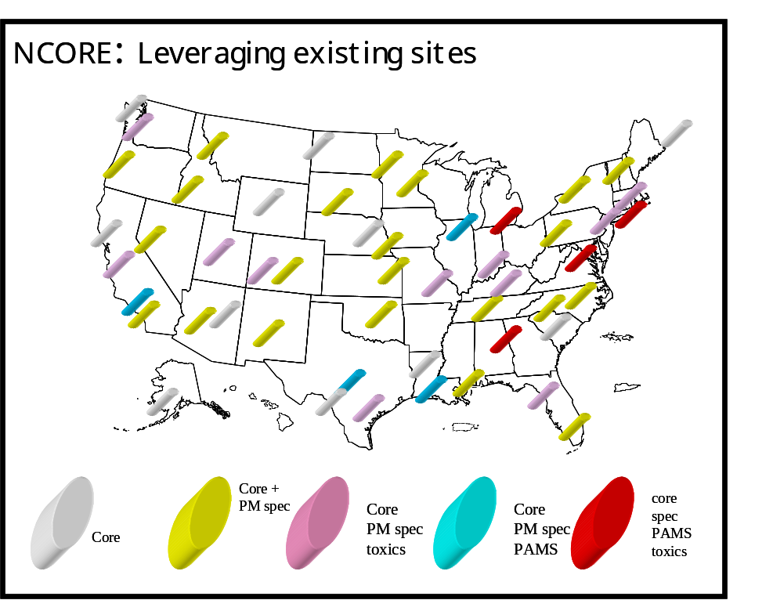
Figure 5. Potential of developing a national system of collocated measurements through
leveraging existing networks. The number of collocated measurements would depend
on the number of supported networks addressed at a particular location.

The NCore rationale assumes that there are inherent efficiencies and synergistic information gains derived through a wealth of collocated measurements. Theoretical efficiencies derived through economies of scale gains include reduced operator travel time and centralization of maintenance supplies, system quality assurance audits and instrument housing facilities. Enhanced information gains would accrue through a combination of adding system constraints to the model evaluation process and increasing the number of variables accessible for assessment purposes such as source apportionment and epidemiological studies. These attributes for a monitoring network should be viewed as complementing the strong regulatory design of most existing networks. During early stages of formulating NCore, several concerns were raised that a design not focused on highest concentration areas using Federal Reference Methods (FRMs) was not relevant to perceived mandates of regulatory agencies. Building bridges to the research community, air quality modeling platforms and eventually to other observational platforms (e.g., Satellite and aircraft systems) and environmental media is a key underlying objective of NCore.

NCore data objectives and network attributes. The NCore sites in combination with existing routine networks collectively are intended to address the following objectives, several of which were highlighted in the 2004 National Academy of Sciences Report, “Air Quality Management in the United States:”

- Timely data reporting based on continuous monitors through AIRNow and related air quality forecasting and public reporting mechanisms;
- Emission strategy development, primarily by supporting air quality model evaluation and other observational methods;
- Accountability – a assessing progress of implemented rules and programs through tracking long term trends of criteria and non-criteria pollutants and their precursors;
- Epidemiological studies that contribute to ongoing reviews of the NAAQS;
- Research support ranging across technological, health, and atmospheric process disciplines;
- Ecosystem assessments recognizing that national air quality networks benefit ecosystem assessments and, in turn, benefit from data specifically designed to address ecosystem analyses; and
- Compliance through establishing nonattainment/attainment areas through comparison with the NAAQS
The following design attributes are used to promote integration themes, technological improvements and system efficiencies which collectively position the NCore network to address multiple data objectives listed above.

Collocated multiple pollutant measurements. Air pollution phenomena across ozone, particulate matter, other criteria pollutants and air toxics are more integrated than the existing single pollutant program infrastructure suggests. From an emissions source perspective, multiple pollutants or their precursors are released simultaneously (e.g., combustion plume with nitrogen, carbon, hydrocarbon, mercury, sulfur gases, and particulate matter). Meteorological processes that shape pollutant movement, atmospheric transformations and removal act on all pollutants. Numerous chemical/physical interactions exist underlying the dynamics of particle and ozone formation and the adherence of air toxics on surfaces of particles. The overwhelming programmatic and scientific interactions across pollutants demand a movement toward integrated air quality management (Scheffe et al., 2007). Collocated air monitoring will benefit health assessments, emission strategy development, and monitoring. Health studies with access to multiple pollutant data will be better positioned to tease out confounding effects of different pollutants, particularly when a variety of concentration, composition and population types are included. Evaluation of air quality models, which drive development of emission strategies underlying air program policy, benefit through constraints imposed by multiple variables thereby reducing probability of compensating errors. Just as emission sources are characterized by a multiplicity of pollutant releases, related source apportionment models yield more conclusive results from use of multiple measurements. Multiple measurements streamline monitoring operations and offer increased diagnostic capabilities to improve instrument performance. In addition, as we move aggressively to integrate continuous PM (e.g., both mass and speciation) monitors in the network, it is important to retain a number of collocated filter and continuous instruments as the relationships between these methods now are subject to future changes brought on by modifications of aerosol composition. For example, assuming proportionally greater sulfur reductions, aerosol nitrate gradually will replace sulfate which in turn could lead to increased measured mass attrition with nitric acid volatility losses from Teflon filters. Given that we cannot measure everything everywhere within a constrained resource environment, a natural conflict arises between the relative value of spatial richness versus multiple parameters at fewer locations. It is assumed that the diagnostic value attained from combining measurements at fewer locations is greater than that derived from single species measurements at more locations. Part of this assumption recognizes an increased merging of models and observations. As model behavior is improved through multiple collocated measurements, the lack of spatial richness in observed fields can be complemented by model, or hybrid model-observation, generated spatial and temporal characterization fields.

Emphasis on continuously operating instruments. Continuously operating in-situ instruments provide near immediate data delivery enabling processing through reporting tools such as AIRNow that effectively inform the public of near term air quality conditions. Continuous data add insight to health assessments addressing sub-daily averaging times, source apportionment studies relating impacts to direct emission sources, and air quality models predicated on capturing diurnal air quality patterns.

Diversity of “representative” locations, across urban (large and medium size cities) and rural (characterize background and transport corridors) areas. National level health assessments and air quality model evaluations require data representative of broad urban (e.g., 5 to 40 km) and regional/rural (> 50 km) spatial scales. Long term epidemiological studies that support review of national ambient air quality standards benefit from a variety of airshed characteristics across different population regimes. The NCore sites could be utilized to support development of a representative report card on air quality across the nation, capable of delineating differences among geographic and climatological regions. While “high” concentration levels will characterize many urban areas in NCore, it is important to include cities that also experience less elevated pollution levels or differing mixtures of pollutants for more statistically robust assessments. It also is important to characterize rural/regional environments to understand background conditions, transport corridors, regional-urban dynamics, and influences of global transport. Air quality modeling domains continue to increase. Throughout the 1970's and 80's localized source oriented dispersion modeling evolved into broader urban scale modeling (e.g., Urban Airshed Modeling for ozone) to regional approaches in the 1980's and 1990's (e.g., Regional Oxidant (ROM) and Acid Deposition (RADM) Models to current national scale approaches (Models 3- CMAQ) and eventually to routine applications of continental/global scale models. The movement toward broader spatial scale models coincides with increased importance of the regional/rural/transport environment on urban conditions. As peak urban air pollution levels decline, slowly increasing background levels impart greater relative influence on air quality. Models need to capture these rural attributes to be successful in providing accurate urban concentrations.

Network Assessments

EPA commissioned a national assessment of our monitoring networks in 2000, with
considerations for population, pollutant concentrations, pollutant deviations from the NAAQS,
pollutant estimation uncertainty, and the area represented by each site. Based on this national
assessment, it was determined that substantial reductions in monitors could be made for pollutants which are no longer violating national air standards on a widespread basis, namely
lead, sulfur dioxide, nitrogen dioxide, and PM10, with the caveat that the measurement of some
pollutants, such as sulfur dioxide, may be useful as source tracers even though ambient levels
may be low. Even for those pollutants of greatest national concern, ozone and PM2.5, sufficient
redundancy was found to suggest site reductions of 5 to 20% without seriously
compromising the collective network information value from a spatial characterization perspective. This national assessment catalyzed efforts across the 10 EPA Regional Offices, a process incorporated in the monitoring regulations to be revisited every five years. However, the procedures by which regional assessments were conducted were not standardized, although differences in air quality, population, monitoring density, and objectives suggest flexibility in evaluating networks. Recognizing the desire for consistency, the monitoring Subcommittee of the Clean Air Science Advisory Committee (CASAC) met in July 2003 and recommended that regional assessment guidelines be developed for subsequent regional assessments at five year intervals (EPA, 2007). Network assessments are collaborative efforts among EPA and States, local agencies and Tribes which incorporate objective statistical evaluations along with local and policy based considerations bearing on local decisions to change monitors. Ideally, the combined efforts among national, regional, and local perspectives and needs will result in an optimized realignment of air monitoring networks which will be more efficient, yet more responsive to the many objectives of the Strategy.

Overview of the National Assessment for Ozone

An example national assessment of the criteria pollutant networks was conducted in 2000 to catalyze subsequent regional level assessments. This assessment considered concentration level, site representation of area and population, and error uncertainty created by site removal as weighting parameters used to determine relative “value” of individual sites. An indication of site redundancy was estimated through an error analysis based on site by site subtraction. The national assessment calculated error uncertainty by modeling (i.e., interpolating between measurement sites) surface concentrations with and without a specific monitor with the difference reflecting uncertainty (Figure 4). Areas of low uncertainty (e.g., less than 5 ppb error difference for ozone) suggest that removal of a monitor would not compromise the ability to estimate air quality in the region of that monitor as nearby stations would adequately capture air quality spatial features with or without the removed site.

The assessment approach was expanded to include additional weighting factors beyond error. Typical outputs for ozone networks (Figure 5) suggest that ozone sites clustered in urban areas yield less powerful information than sites located in sparsely monitored areas, especially in high growth regions like the southeast. However, this conclusion is more applicable to urban areas with more homogeneous conditions. This methodology was applied to all criteria pollutants with a variety of weighting schemes to provide a resource for more detailed regionalized assessments.

Key findings of the national network assessment addressed basic investment and divestment considerations consistent with the NCore design attributes discussed above, and reflect both new requirements and themes in recent monitoring regulations as well the broader evolution taking place across national monitoring networks over the last decade.

Investment Opportunities. New monitoring efforts are needed to support new air quality challenges, including monitoring for air toxics and new technology for criteria pollutants and precursor species. Air toxics have emerged as a top public health concern in many parts of the country, and a national air toxics monitoring network addressing national consistency through the national air toxics trends sites (NATTS) and community specific issues has evolved since 2001. New technology, especially continuous measurement methods for pollutants, such as fine particles, are needed to provide more complete, reliable, and timely air quality information, and to relieve the burden of manual sampling. Resources and guidance are needed for this activity. These recommendations reflect a community wide consensus formed around 2003, yet remain relevant and consistent with recommendations generated by the 2004 National Academy of Sciences (NAS) report, Air Quality Management in the United States (NRC, 2004).

Divestment Opportunities. Opportunities exist to reduce existing monitors resulting in more efficient use of existing monitoring resources and potentially support new monitoring initiatives. Many historical criteria pollutant monitoring networks have achieved their objective and demonstrate that there are limited if any, national or regional air quality problems for certain pollutants, including PM₁₀, SO₂, NO₂, CO and Pb. A substantial reduction in the number of monitors for these pollutants should be considered. Consideration to retaining, and relocating, a certain number of trace level SO₂ and CO monitors to support air quality and emissions model evaluation and source attribution analyses. Several monitoring sites with only one (or a few) pollutants should be combined to form multi-pollutant monitoring stations. Any resource savings from such divestments must remain in the monitoring program for identified investment needs. A reasonable period of time is required to smoothly transition from established to new monitoring activities. Undoubtedly, divestments in current monitors will be interpreted by some as a diminished general appreciation of those observations. In most cases, the opposite perspective is true. Observations of CO, SO₂, NO₂ may be as important as any observation given the roles of those observations in a variety of health, deposition and atmospheric science assessments and are especially critical to forwarding multiple pollutant assessments. While lead is a national success story with regard to existing air quality standards, findings from recent health studies and related EPA NAAQS reviews have catalyzed probing of the adequacy of ambient lead monitoring programs.
Policy Issues. Removal or relocation of monitors with historical regulatory applications creates a challenging intersection of policy and technical applications. Network assessments produce recommendations on removing or relocating samplers based largely on technical merit. In some instances, these recommendations conflict with existing policy or other needs. For example, a recommendation that an ozone monitor be discontinued in a “nonattainment” county due to redundancy of neighboring sampling sites creates a conundrum crossing policy and technical perspectives. It should not be assumed that policy should override a technical recommendation, nor should technical approach override existing policy. Rather, reasonable solutions can be achieved on a case-by-case basis.
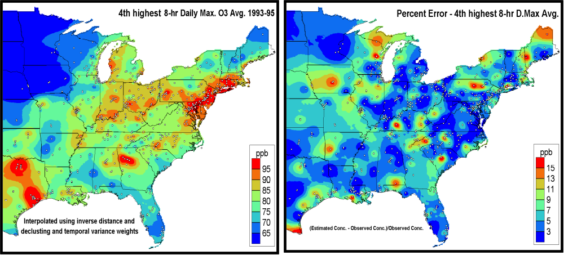
Figure 4. Surface depiction of estimated absolute errors (right) in ozone concentrations produced by removing existing monitors on a site by site basis, relative to base case (left). Areas showing low errors (<5 ppb) suggest neighboring monitors could accurately predict ozone in area of a removed site. Areas of high error suggest necessity to retain existing monitors and perhaps increase monitoring.

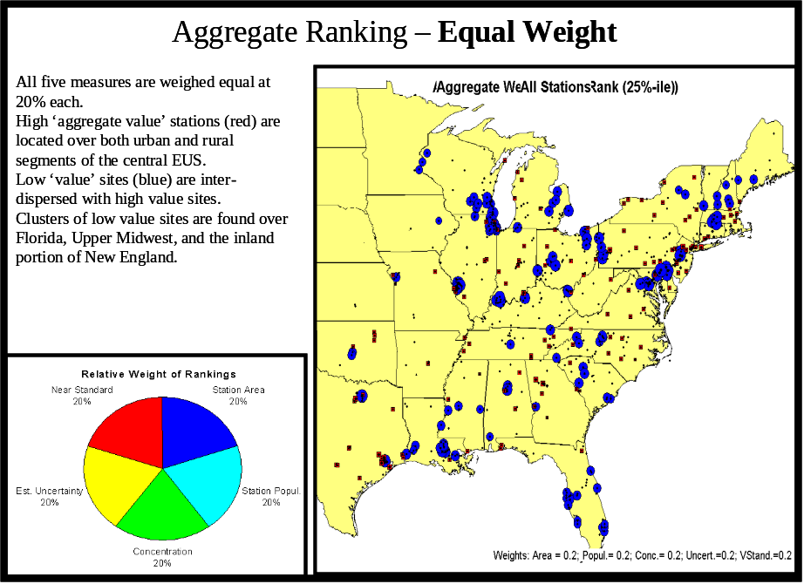
Figure 5. Aggregate assessment of 5 evenly weighted factors. Blue circles and red
squares indicate the lowest and highest valued sites, respectively.

Promoting flexibility and advanced technologies.

The PM2.5 network initiated in 1999 incorporated over 1100 gravimetric, filter based sampling methods meeting Federal reference or equivalent method (FEM/FEM) status, which is required for regulatory applications such as developing design values relative to the NAAQS for establishing an area’s attainment status. Gravimetric methods are labor intensive, typically sample over 24 hour time frame thereby losing important temporal resolution, and create significant data delivery delays due to laboratory processing. Consequently, there has been broad scale desire to use continuously operating PM_{2.5} monitors for over a decade. Continuous samplers are used widely by the AIRNOW program to inform the public of an area’s air quality related to the air quality index (AQI). Unfortunately, the lack of equivalency demonstrations for such methods has curtailed broader use of continuous aerosol data. Continuous PM methods are subject to a variety of measurement artifacts, driven largely by variable volatility across aerosol components and influenced by measurement principal deployed, composition of aerosols sampled and meteorological variables such as temperature and relative humidity. These artifacts often produced relationships to the FRM with geographic and seasonal differences complicating a national demonstrations of equivalency. To address the issue of regional variability in the response of continuous methods relative to FRMs, EPA developed a new category for Class III FEM requirements referred to as Approved Regional Methods (ARMs).

These comments on continuous PM measurements as well as earlier discussion regarding Level 3 NCore sites reflect a small sample of a plethora of technological and resource issues in the ambient monitoring field. The lack of well defined market incentives, policy constraints of regulatory agencies and the supportive role of technology all compromise technological advancements in ambient monitoring instrumentation.

NEXT STEPS

Modifications in the nations routine networks catalyzed by the monitoring strategy will facilitate broader integration of observation systems across Federal agencies, countries, satellite based sensors and research efforts to address the myriad of challenges spanning across a variety of pollutant categories, spatial scales and environmental media. An acceleration of partnerships across agencies and nations is occurring, driven by a combination of dwindling assessment resources, increased analytical demands and greater recognition of co-dependencies associated with environmental assessments. In addition to multiple pollutant interactions discussed here, the challenges of multiple spatial scale assessments will drive future integration of networks. Gradual lowering of U.S. ozone and particulate matter standards combined with enhanced growth of emissions in developing regions of Eastern Asia will increase the relative contribution of hemispherical air pollution transport to regional and local areas, driving assessment approaches that benefit from complimentary use of air quality models and ground and satellite based air quality observations. Interactions between climate and air quality affecting U.S. air quality are assessed through observations and modeling tools that also support long range transport scenarios. Local scale air quality assessment challenges include a broad suite of particle physical property and atmospheric chemistry phenomena associated both with current exposure to near roadway environments, and challenged by atmospheric composition modifications effected by penetration of emerging fuels and other technologies enabled through energy and environmental policies addressing greenhouse gas emissions. Currently, our networks with “representative” monitoring siting are not positioned to characterize adequately the atmosphere in near roadway environments proximate to substantial populations. Resource burdens associated with the complex near field environments suggest some type of flexible arrangement where environments are measured periodically to reduce resource burden and provide long term temporal context. Consequently, observation networks needs to expand from a current regional and urban focus to simultaneously embrace global and local scale issues.

This assortment of multiple demands implies resource needs beyond the scope of routine networks, and places a premium on partnerships with entities sharing overlapping assessment needs. Furthermore, the complexity of space, time and compositional needs leads to increased merging of observations and modeling tools (Figure 6), as it is not practical to cover such a diverse set of needs through observations only.

Accessing and manipulating observational data sets presents challenges to data user groups accessing single systems. Information technology solutions to harmonize data sets could reduce the burden on analysts in accessing, reducing, understanding and manipulating a spectrum of disparate data sets inherent in integrated assessments. Resources for collecting data rarely are complemented by adequate resources to process and analyze information. Demands on data processing elements necessarily will increase as the breadth of assessments expands through integration drivers. Examples of recently developed publicly accessible user friendly air quality data reduction, integration and analysis/visualization efforts include the Visualization Information Exchange Web System (VIEWS - http://vista.cira.colostate.edu/views/) developed by the Regional Planning Organizations (RPOs) in support of visibility assessments and the Health Effects Institute’s (HEI - http://hei.aer.com/login.php) air quality data base.

The federated data system (DataFed - http://datafedwiki.wustl.edu/index.php/DataFed_Wiki) is an outgrowth of the Global Earth Observation System of Systems (GEOSS), an attempt to coordinate Earth observations catalyzed by the Group on Earth Observations (GEO, http://www.earthobservations.org/index.html). DataFed provides the architecture to facilitate interoperability of data systems from diverse organizations (Figure 6), and conceptually could link surface based air quality data integration systems such as VIEWS with observational and modeling systems expanding the range of environmental characterization relevant to comprehensive integrated environmental assessments. These emerging integrated systems offer vision potential for addressing information technology facets of comprehensive assessments, but
will require elevated investments and engagement from supporting and user communities.
Figure 6. Complementary attributes of observations and models enhancing environmental characterizations.

References:

EPA, 1997, National Ambient Air Quality Standards for Particulate Matter; July 18, 1997, 40 CFR Part 50

EPA, 2006a, National Ambient Air Quality Standards for Particulate Matter; Final Rule October 17, 2006, 40 CFR Part 50

EPA, 2006a, Revisions to Ambient Air Monitoring Regulations, CFR Parts 53 and 58, vol 71FR 61236, October 17, 2006

EPA, 2005, Draft Version of the National Ambient Air Monitoring Strategy, December, 2005, http://www.epa.gov/ttn/amtic/monstratdoc.html

NRC, 1998, Research Priorities for Airborne Particulate Matter I: Immediate Priorities and a Long-Range Research Portfolio, National Academy Press, Washington D.C.

NRC, 1999, Research Priorities for Airborne Particulate Matter II: Evaluating Research Progress and Updating the Portfolio, National Academy Press, Washington D.C.

NRC, 2001, Research Priorities for Airborne Particulate Matter III: Early Research Progress, National Academy Press, Washington D.C.

NRC, 2004. National Research Council, 2004, Air Quality Management in The United States, National Academies Press

Scheffe, R.S.; Hubbell, B.; Fox, T., Rao, V.; Pennell, W. The Rationale for Multipollutant, Multimedia Air Quality Management Framework; EM, May, 2007, 14-20.

EPA, 2007 http://www.epa.gov/ttn/amtic/files/ambient/pm25/datamang/network-assessment-guidance.pdf Ambient Air Monitoring Network Assessment
Guidance: Analytical Techniques for Technical Assessments of Ambient Air
Monitoring Networks

