AIR DISTRICT POST-WILDFIRE REPORTING FORM

To be completed and forwarded to the Air District within 90 calendar days after the fire is declared out.

A. GENERAL INFORMATION:

WILDFIRE Name/Number |  |  | CA-YNP-1473_Cascade |  | Air District Permit Number |  | 2011-0901
Legal Location | Latitude 37.7696°  Longitude -119.675° |  |  | Wildfire Acres |  | 1677
Landscape location Desc. |  | Located near the top of the Cascade Creek drainage, about midway between the Merced and Tuolumne River Drainages (see Figure 1) in red fir forest between 7000-9000 ft (2100-2800m) ASL.

B. WILDFIRE INFORMATION:

Date Of Burn | Burn Day  Status* | Ignition  Time | Planned  Acres | Actual  Acres** | Tonnage  Consumed*** | Completion Date  Of Burn
6/16/2010 | Fair | N/A | N/A | 1677 | n/a | 11/19/2012

*Burn Day Summary for 2012 is located in Table 2;
**Non-burnable areas were clipped out (see Figure 3)
***Note that the EES model output (Table 1) does not yield a consumption value

C. EMISSIONS INFORMATION:

POLLUTANT | EMISSIONS (tons/burn, see also Table 1)
PM-10 | 479
PM 2.5 | 407
Other Pollutants | See Emissions Model Results (Table 1)

Complete the following for burns greater than 250 acres, burns that created smoke impacts or burning on a no burn day.

D. NARRATIVE INFORMATION:

- Was this burn conducted as per the Smoke Management Plan’s air quality conditions? Yes, with the caveat that we don’t plan wildfires and therefore do not have the ability to plan or manage emissions with the precision or control typically expected from a prescribed fire. The air district permit # 2011-0901 documents and specifies Yosemite’s joint commitments with Mariposa APCD to manage smoke from this fire.

- Were there any smoke impacts, including impacts to Smoke Sensitive Areas, neighboring air districts and or states? If yes, list areas and duration of impacts. The definition of the term “smoke impact” depends on whether smoke impacts are defined by influence (PM_{2.5} levels, sight or smell) or by health-based metrics. Although there were no health impacts (i.e., no NAAQS exceedances) at any of our smoke sensitive sites (SSNs) attributable to the Cascade fire, there was influence, including influence likely due to other fires at some of our monitoring sites while the Cascade was burning. Table 1 and Figures 3-4 summarize PM₁₀ fire emissions based on fire growth and our vegetation mapping efforts. Figure 8 summarizes impacts relative to the AQI scales given in the toolkit for Public Health officials at the California Air Resources Board (data and larger figures are available upon request). Of our 5 deployed PM_{2.5} monitors (Figure 7) in Foresta and Yosemite West detected the strongest likely Cascade fire influence (i.e., relatively elevated concentrations). However other fires appeared to have just as much, if not more influence on concentrations at our monitors as the Cascade fire, especially on the east site monitoring site in Lee Vining (Figure 9). Periods of regional and local influence coinciding with the periods of maximum emissions are shown with HMS and MODIS imagery (Figure 5), and webcam images from both the Turtleback East and the Crane Flat webcam (Figures 6). Timelapse of the webcam images, the MODIS images, and all HMS graphics are available upon request.

- Number of complaints received? (Forward complaints to Air District) None.

- List contingency actions initiated to reduce impacts. Substantial proactive analysis was taken early on (Figures 1,2) in the response to the detection of the Cascade fire, and revisited midcourse in late August. The analysis showed that our landscape features and topography, including the footprints of previous fires would limit spread of the fire to very small daily increments, resulting in minimal emissions and impacts. The postburn data support our assessment, with no NAAQS exceedances attributable to this fire (Figure 9) and an average estimated emissions levels of 3.9 tons PM₁₀/day (Figure 4).
  - Specifically, spread to the east and north was limited by large expanses of bare granite. Fuels were more continuous to the south and west, but topography on these flanks dictated that the only way for the fire to spread was by backing and flanking down the hill against prevailing winds. Furthermore, because fires at these elevations in these sparse fuel types dominated by patchy clumps of red fir are not able to spread very quickly without the aid of a significant wind event, it was determined that no action beyond monitoring was needed to check the spread of the fire and keep emissions below thresholds that would lead to smoke impacts (Figure 4). Historically, these thresholds have been in the range of about 10-15 tons PM₁₀ /day for poor dispersion and 30+ tons PM₁₀/day for fair to good dispersion.
  - Later in the season, as the fire began to encroach on long needle pine vegetation types that could allow the fire to spread in to lower elevation, more volatile fuels, it was determined that some hand line (Figure 3) would be needed to check spread on the lower south and west perimeters. These actions prevented some additional emissions; though any air quality benefits were likely negligible due to the already minimal impacts the fire was having at our SSNs (Figure 9). After these actions were taken, daily emissions dropped significantly (Figure 4).

- List recommendations to utilize for future burns in this area to minimize impacts.
  - Preserving the landscape mosaic: Minimizing impacts does not necessarily require minimizing emissions, rather just keeping emissions low enough on a per day basis that AQ impacts do not occur, or limiting the duration of those emissions if impacts are unavoidable. The Cascade fire was a rare example of the former case, burning in a strategic patch of fuel that had not seen fire for decades (Figure 2) and doing so without creating AQ impacts and with minimal intervention. The more fires we can allow in areas like this, the greater the likelihood that our landscape mosaic will keep growth and emissions on future fires below thresholds that result in AQ impacts.
  - Higher elevations fuels where snow persists: The area where the Cascade fire started is normally too wet to burn most of the year. Fires that do start in areas like this do not usually get very large, so the Cascade fire is exceptional in both respects. These wet, hard to burn, high elevation areas are commonly dominated by red fir forest type, which thrives in high elevation, shaded (e.g., north facing) areas where snow persists into late spring/early summer (Figure 10). From a fire, landscape, and air quality management perspective these slow burning areas can be thought of as a strategic “backstops” or “catcher’s mitts” for fires that start in the more volatile mixed conifer and quickly burn upslope.
  - Model and fire growth estimate utilization: Probably because the 1000-hr fuels were exceptionally dry this year at that elevation due to drought conditions the previous winter and spring, 14-day growth estimates at the 80th percentile under-predicted spread (Figure 3), and actual fire growth for the modeled period (8/22-9/5) ended up somewhere into the area between the 60th and 80th percentile. Uncertainties with vegetation mapping and, to a lesser extent, fuel moistures to variability in spread and emission estimates.
  - Airshed capacity: This fire resulted in emissions that were consistently low relative to other fire incidents in park history. Total daily emissions for the Cascade Fire were for most of the incident’s duration is estimated to be a maximum of 10- tons PM₁₀/day (Figure 4), with an average of 3.9 tons PM₁₀/day. Our working hypothesis—that health impacts occur for fires emitting more than 10-15 tons PM₁₀/day poor dispersion, and more than 30+ tons PM₁₀/day under fair-good dispersion—remains a useful way to roughly gage potential AQ impacts based on projected emissions.
  - Monitoring site sensitivity: Foresta and Yosemite West seemed the most sensitive to Cascade emissions due to proximity to the fire and elevations within 1000 ft of the elevational layer into which most of the smoke was being emitted (Figures 7,9)
  - Use of meteorology in monitoring: Our use of an instrument equipped with meteorological equipment enabled analysis using state of the art tools (i.e., bivariate polar plots) that allow for quick, and at least qualitative interpretation of the effect of wind speed and direction on concentration (Figure 8). Going forward, we recommend expanding the use of meteorological equipment on BAM and EBAM monitors so that tools like this can give us more refined understanding source-receptor relationships.

- Was the burn successful with regards to air quality? Yes. Air quality was minimally impacted even as this rare and strategically important fire burned to large size and successfully treated over 1600 acres in a year where large fires in other areas were burning at high severity over 10’s of thousands of acres. Our landscape and our air quality are more resistant to fire and climate change (Figures 11, 12) as a result.

SUBMITTED BY: Leland Tarnay, Yosemite National Park Air Resources Specialist
DATE: 02/15/2012

Air District Use Only
Staff Reviewer: | Date Reviewed: | Date Logged:
Revision 12/8/00

Table 1. The EES model is very sensitive to 1000hr fuel moistures and overall 1000 hr fuel loading. Fuel moisture data from a nearby site (Badger Pass) show that 1000 hr fuel moistures during the bulk of the emissions was very low, down to 10%, but then increased to around 15% in late September. EES model was run for at both fuel moistures so that we could account for this seasonal variation. See http://www.arb.ca.gov/ei/see/see.htm regarding details on running CARBs emissions models. To arrive at one number, rather than a range of numbers for the purposes of reporting, the two scenarios above were combined, as shown in the table below (all values are in units of tons of the pollutant (e.g., SO₂) in question), and dates (far left column) represent the date that the perimeter in question was measured.

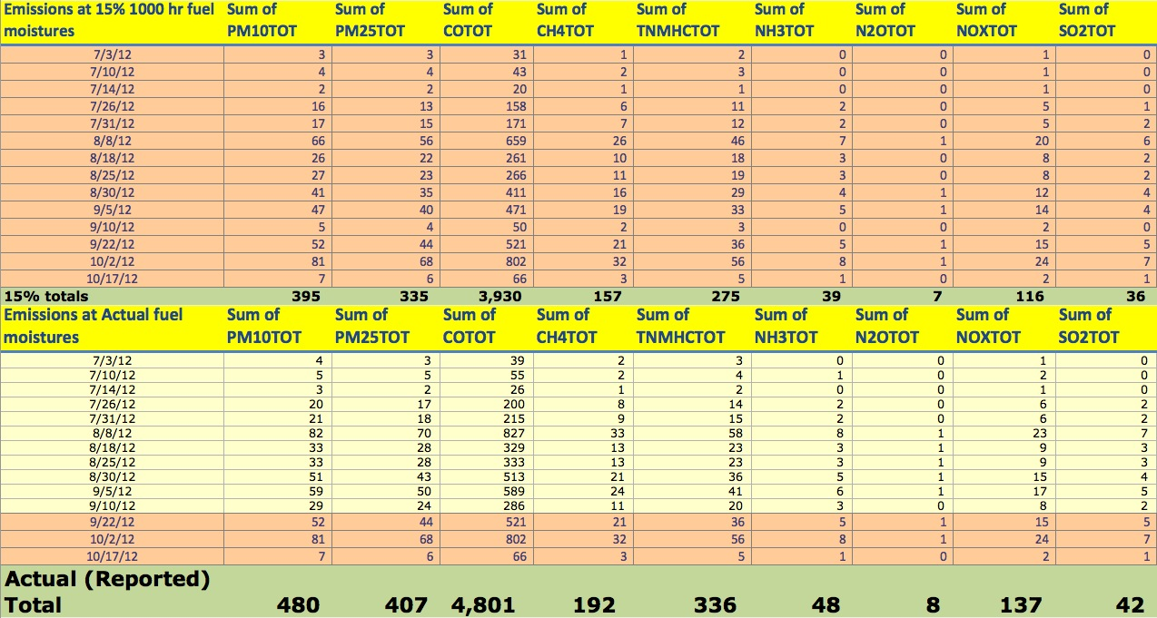
Table 2. Color-coded table of 1998-2012 burn days decisions for South Mountain Counties, adapted from the Air Resources Board Website: http://www.arb.ca.gov/smp/histor/histor. The Cascade fire was detected on the 16th, a no burn day, but did not reach the go/no go threshold until sometime around July 1st or 2nd, which were “fair” burn days.
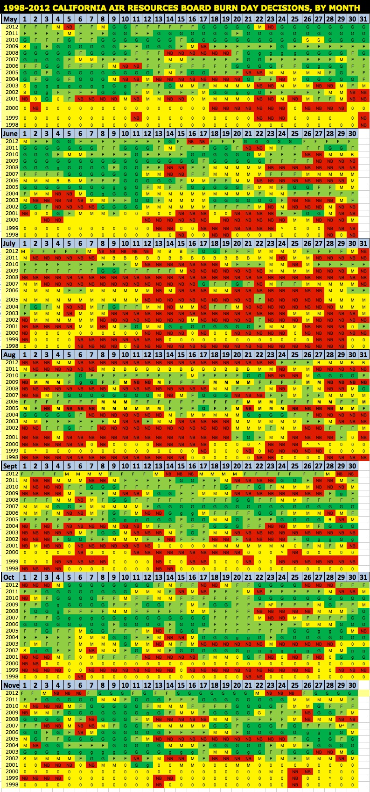
Figure 1. Modeled fire spread for hypothetical fires in the area of the 2012 Cascade WF, modeled for a year similar to 2012 (2008). Low historic rates of fire spread under these conditions contributed to our decision early-on to manage this fire with minimal intervention.
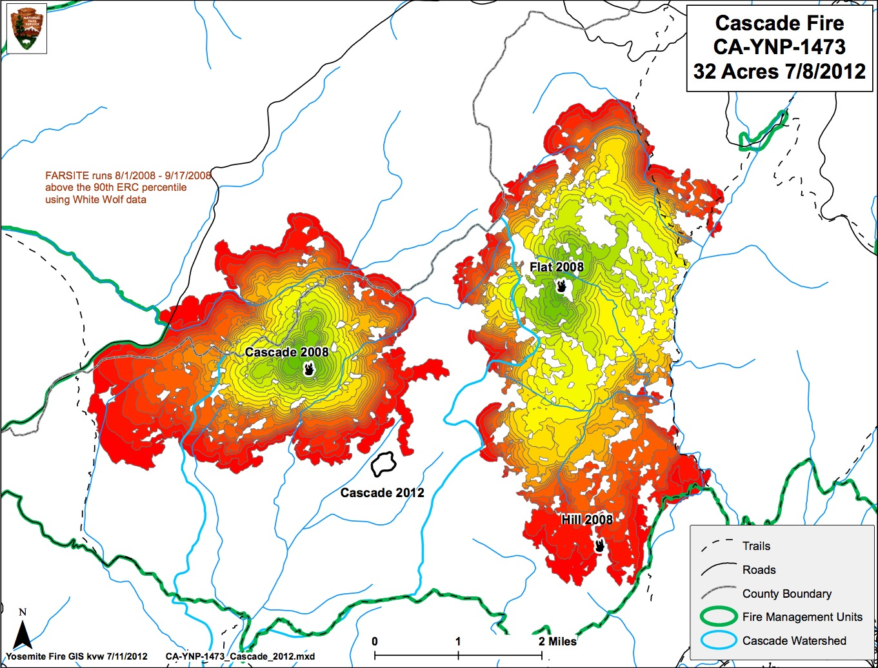

Figure 2. Fire History and Fire spread probabilities for the period from 8/22-9/5/2012, midway through the fire season. Actual fire perimeters for 8/18 and 8/25 are outlined in red.

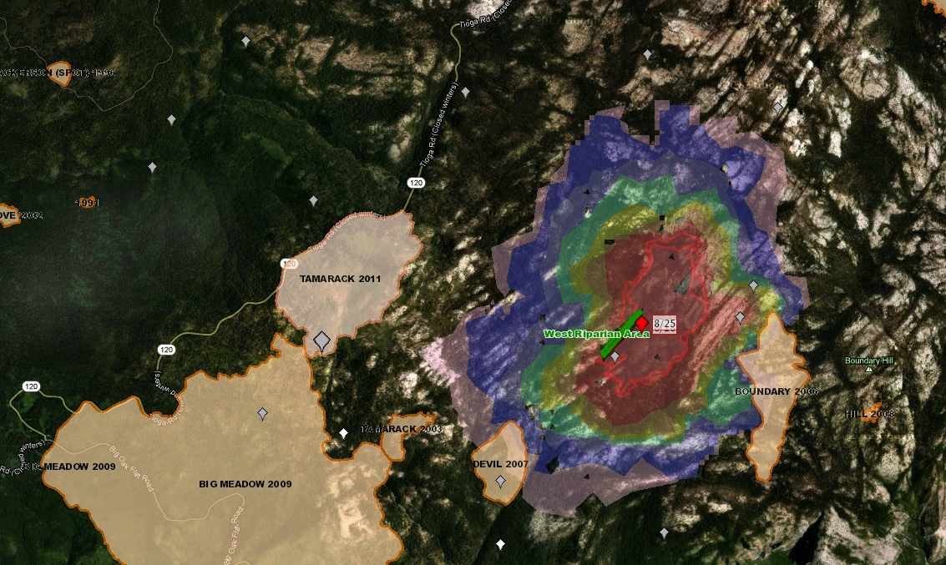
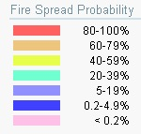

Figure 3. Cascade modeled (FS-Pro) vs actual fire spread, with emissions and EES (http://www.arb.ca.gov/ei/see/see.htm) fuel loading parameter adjustments to account for sensitivity to 1000-hr fuel loads, using crosswalks from a more detailed Yosemite vegetation map. Fire spread models are calibrated to try to include the most likely area to burn at the 80th percentile level (orange crosshatched area), however in this case actual fire spread (blue outlined maroon polygon) exceeded that percentile, to somewhere between the 80th and the 60th percentile level (grey crosshatched area).
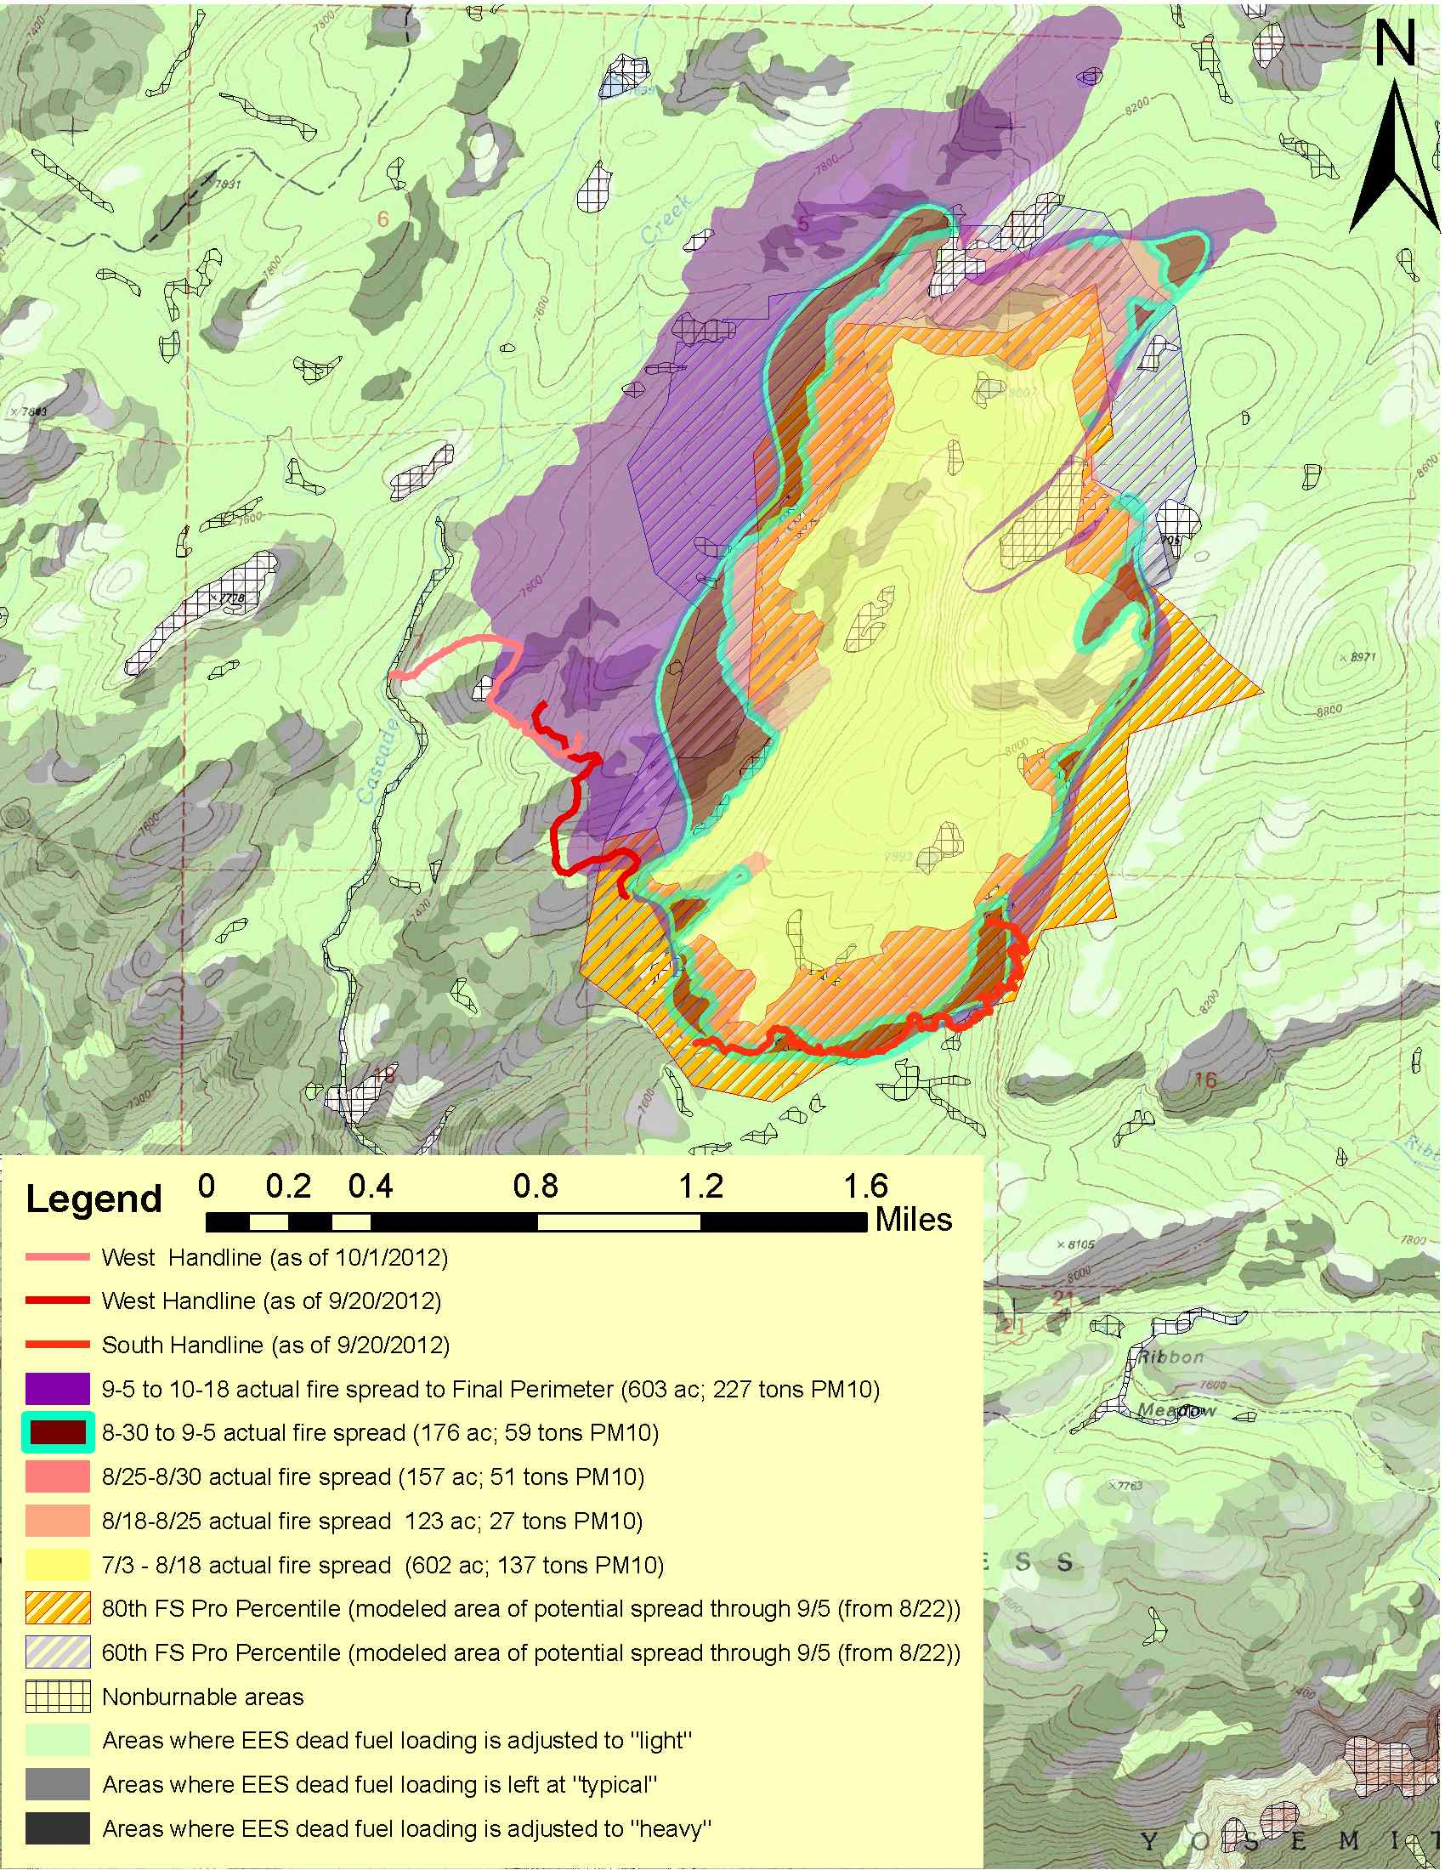
Figure 4. Minimum and maximum emissions, accounting for model sensitivity to variation in fuel moisture (10-15%, 1000-hr fuels). Our working hypothesis, based on previous history and monitoring results the threshold for impacts, is that impacts begin to occur once emissions exceed around 10-15 tons PM₁₀/day under poor dispersion, and 30 + tons PM₁₀/day under fair-to-good dispersion. Average emissions integrated over the period of the fires burning was 3.9 tons PM₁₀/day, and peak emissions were around 10 tons PM₁₀/day in late August. Spread was negligible from Oct 16-Nov 19, the date the fire was officially declared extinguished.
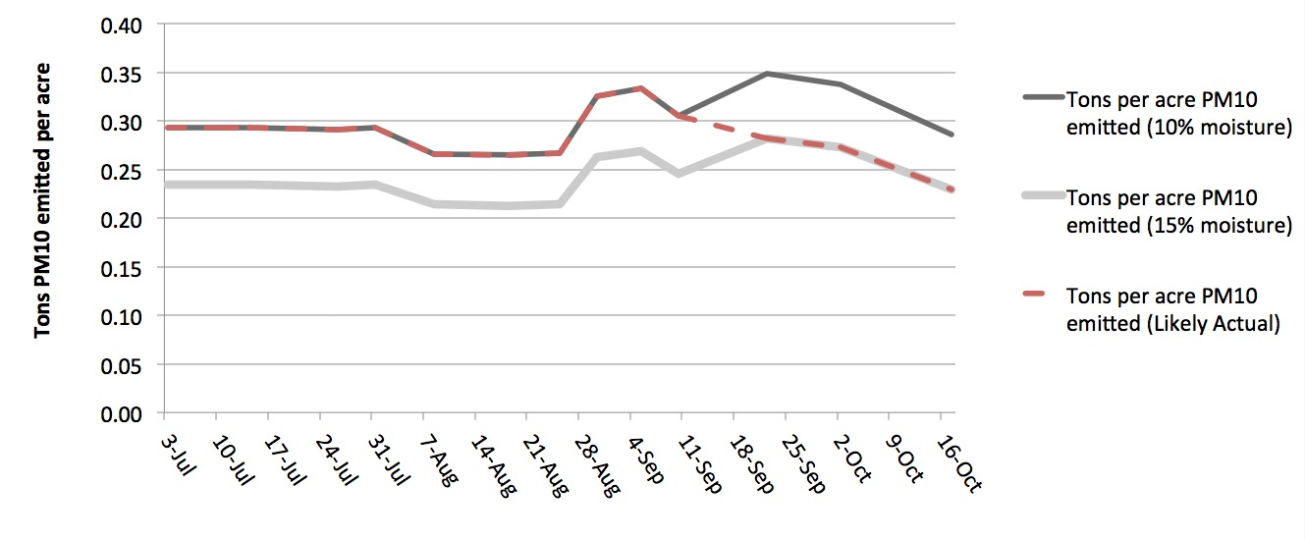
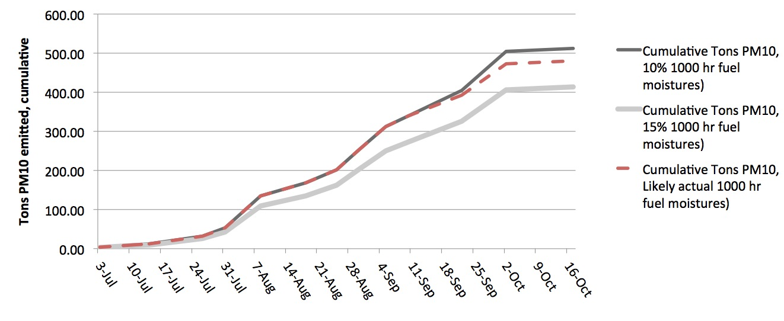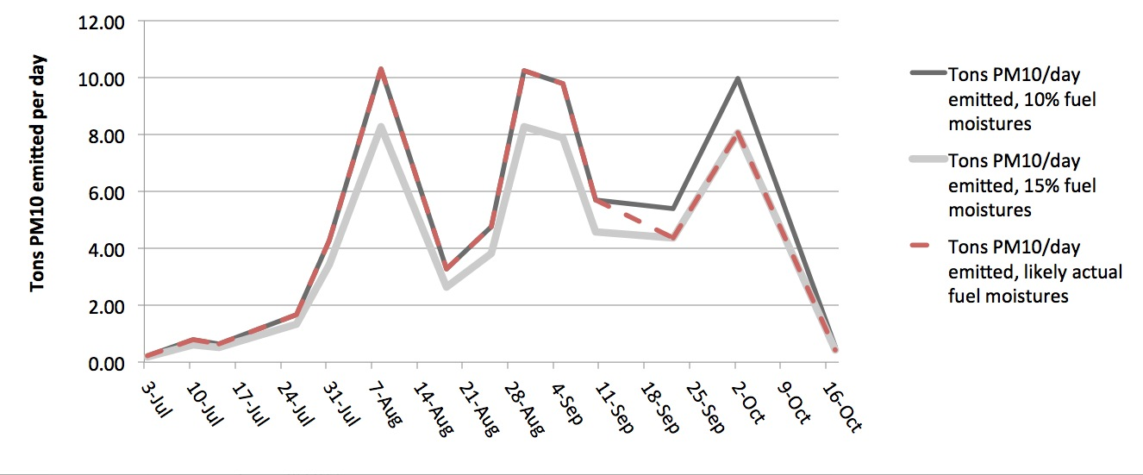
Figure 5. Satellite imagery (MODIS*) and analysis (HMS**) during periods of maximum Cascade fire emissions/impacts. Red dot is the location of the Cascade Fire, note that MODIS satellites are usually overhead during the afternoon, when smoke is least visible from directly above. HMS analysis takes advantage of GOES east imagery, which looks west through smoke over the Sierra Nevada, and is usually more sensitive to smoke.
HMS, 7/26 MODIS 7/26, (aqua)
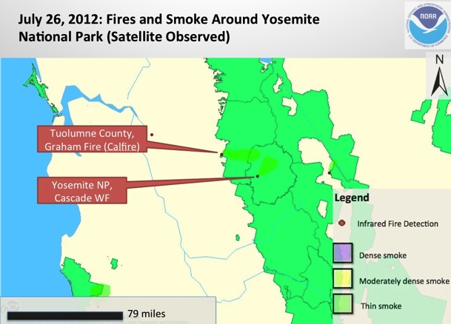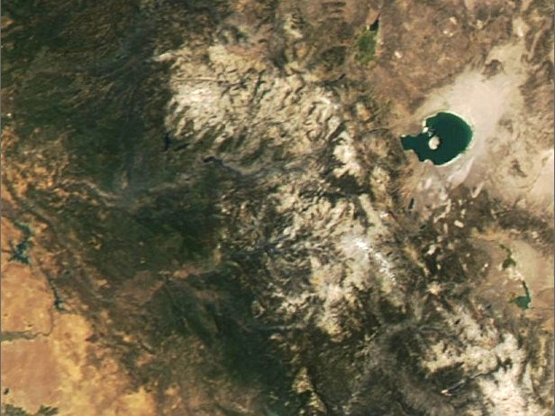
HMS, 8/7 MODIS, 8/7 (aqua)
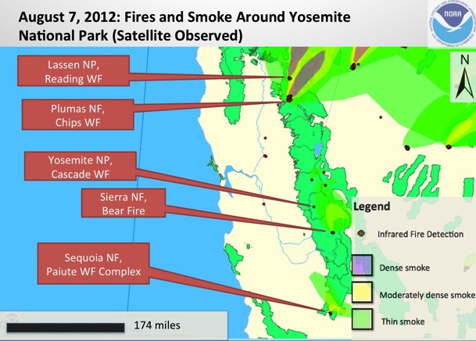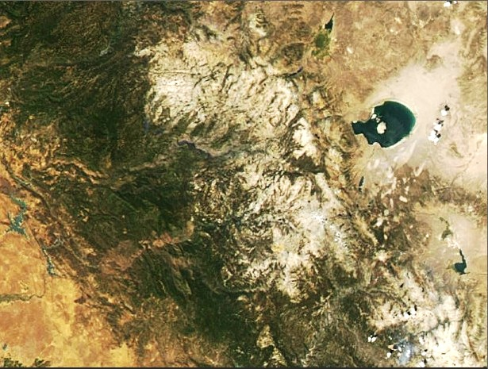
HMS, 9/ 3 MODIS, 9/3 (aqua)
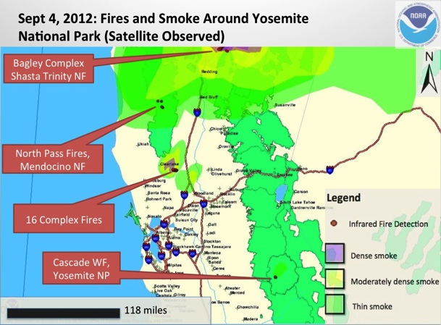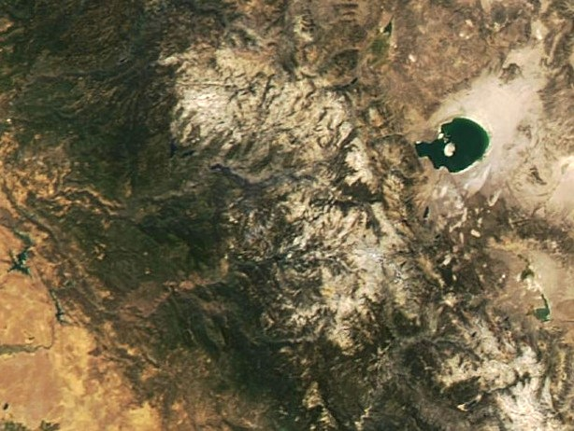
HMS, 9/ 27 MODIS, 9/27 (terra, since aqua had clouds)
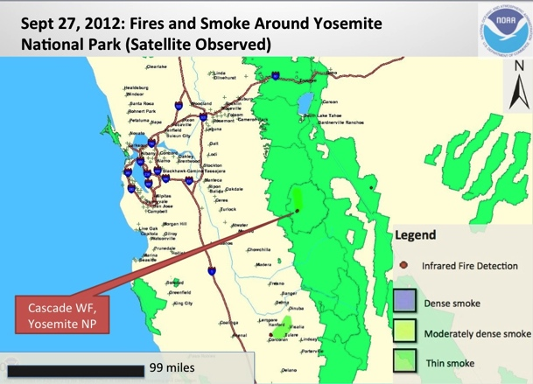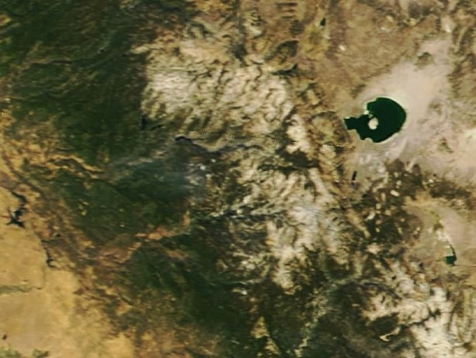

Figure 6. Webcam images at 09:00 PDT for representative webcams, showing clearing smoke from the Cascade Fire, for the same days as in Figure 5 (days with the highest emissions). Turtleback East was pointed directly (east) from Turtleback Dome (see Figure 7) looking through the point where Cascade creek drains into the Merced River canyon. Smoke entrained in nighttime downslope flow from the fire was frequently seen on this camera, especially in the morning, when the rising sun caught the smoke from behind. The Crane flat camera was also pointed east at the fire after 7/10, providing good qualitative information on amount of smoke and direction of transport to corroborate the HMS analysis.
Crane Flat, 0901 7/26 Turtleback East, 0903 7/26
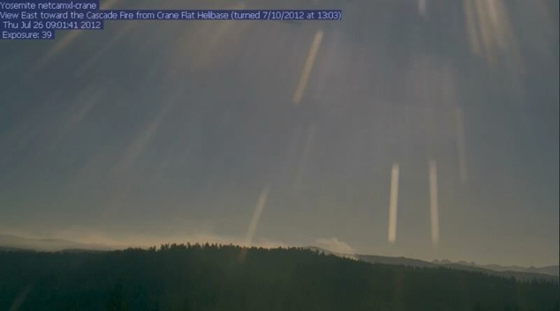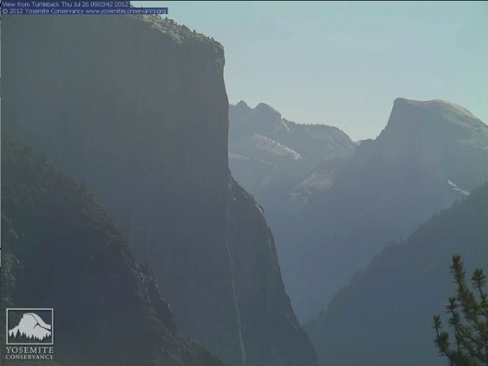
Crane Flat, 0856 8/7 Turtleback East, 0903 8/7
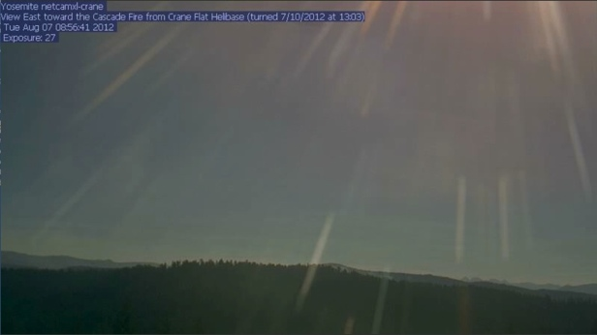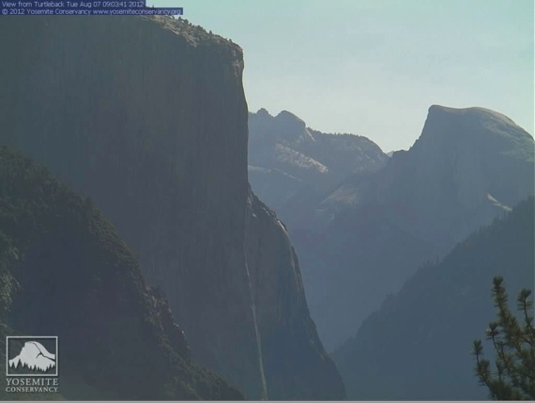
Crane Flat, 0807 9/4 (9/3 not available) Turtleback East, 0921 9/3
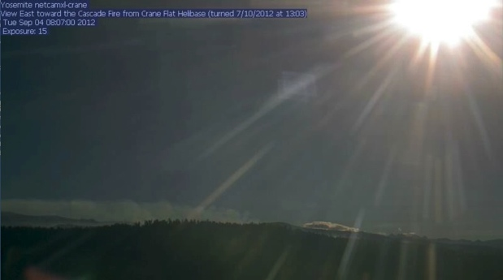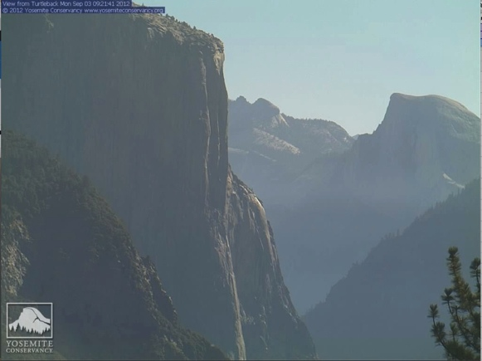
Crane Flat, 0901 9/27 Turtleback East, 0903 9/27
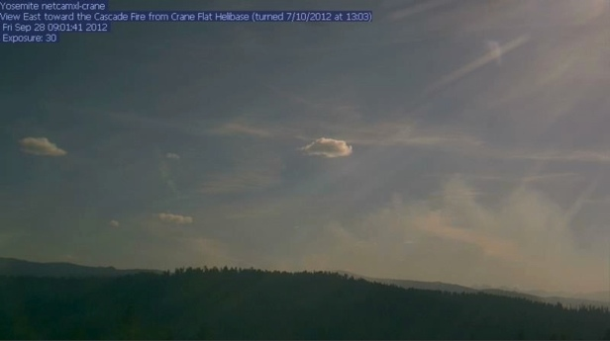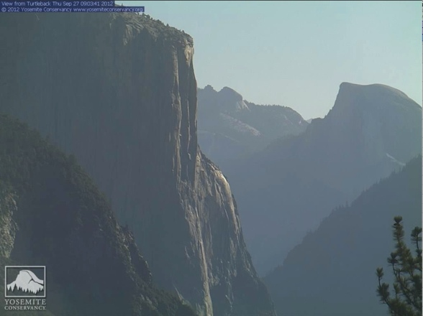
Figure 7. Monitoring and Webcam Locations

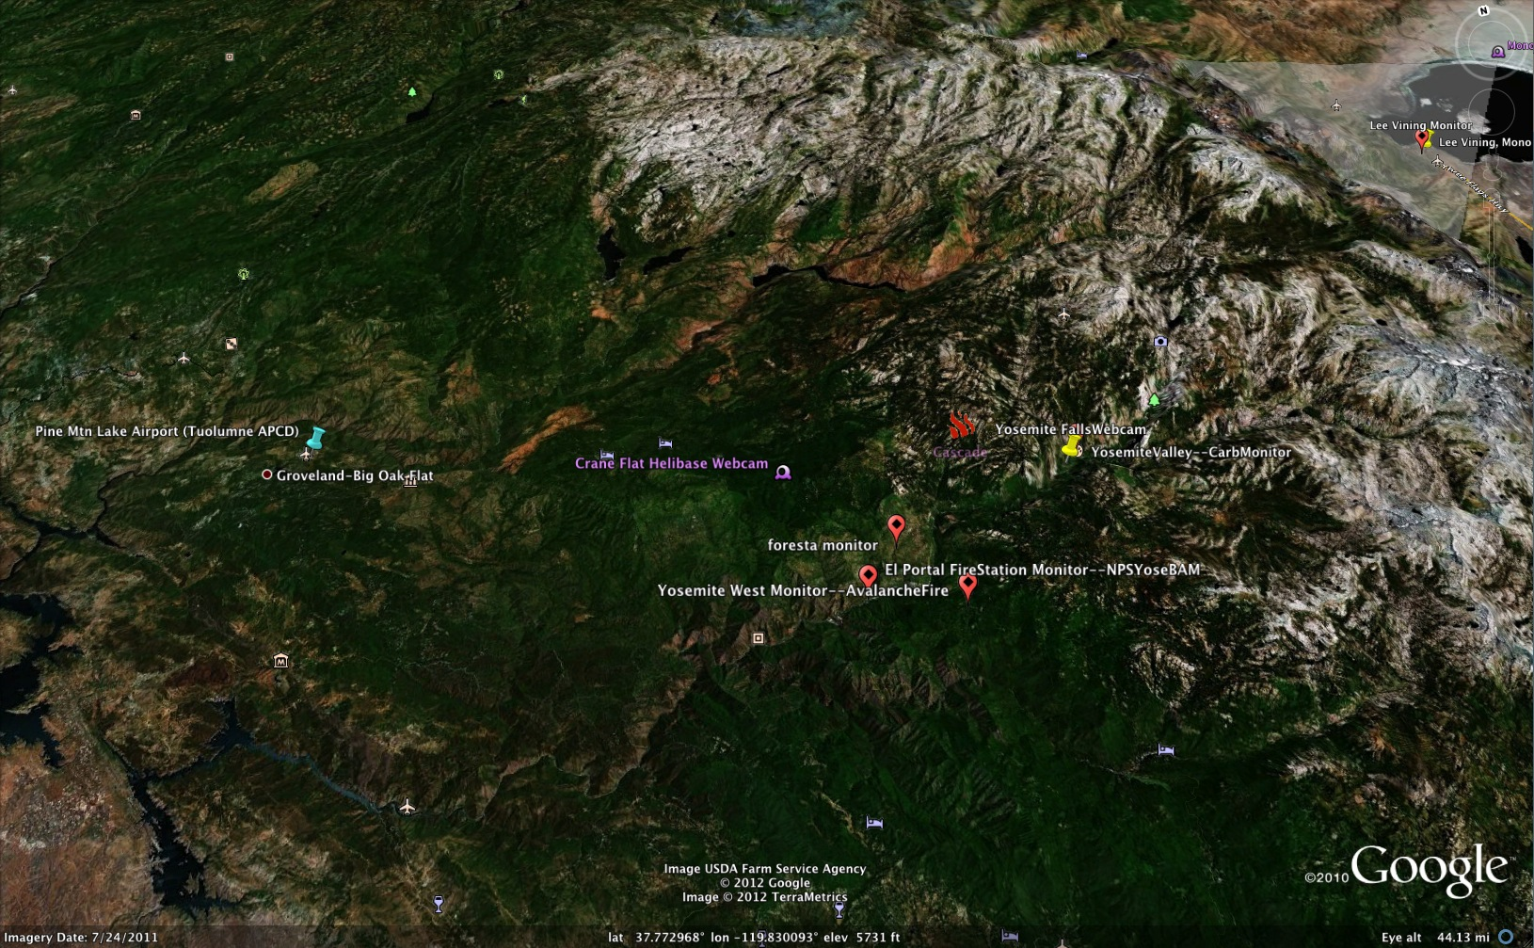

Figure 8. Bivariate polar plots showing median PM_{2.5} concentrations at our Lee Vining site overlooking Mono Lake (µg m⁻³ , colored spectrum) vs. wind speed (m s⁻², dotted radii) and wind direction (NEWS axes) during discrete periods of the summer when the Cascade fire was burning. Wind direction is less meaningful as an indicator of transport at the slower windspeeds than at higher speeds. Inset picture shows the Lee Vining monitoring site looking north over Mono Lake. See http://www.openair-project.org for more references and citations.
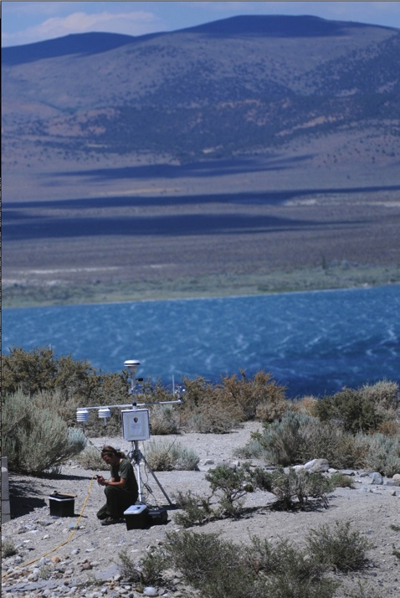
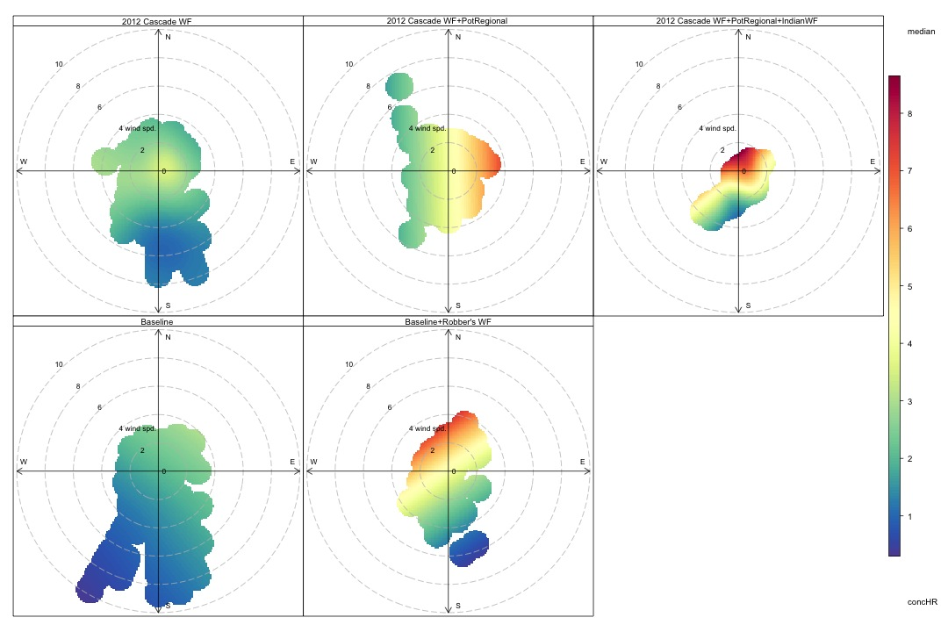

Figure 9. Overview of 24-hr and 3-hr averages for PM_{2.5} monitoring over the course of the Cascade fire, compared to AQI values (background colors) by instrument and site (colored lines). Note that the only health impacts (concentrations above the 24-hr NAAQS, black line) were at Hodgdon (red lines) from a prescribed fire there, not from the Cascade Fire, while the impacts from the Indian Fire caused the impacts at the Lee Vining site. There were no health impacts (concentrations above the 24-hr NAAQS) at any site, though 3-hr averages did exceed briefly USG guidelines* in Foresta once on 8/3, and occasionally put 3 hr average levels into the moderate AQI level (green transparent boxes). Blue transparent boxes show the periods of local influence for other fires. Large fires to the north and east of our region likely influenced our region most strongly from 8/6-8/12 and 8/14-8/24.
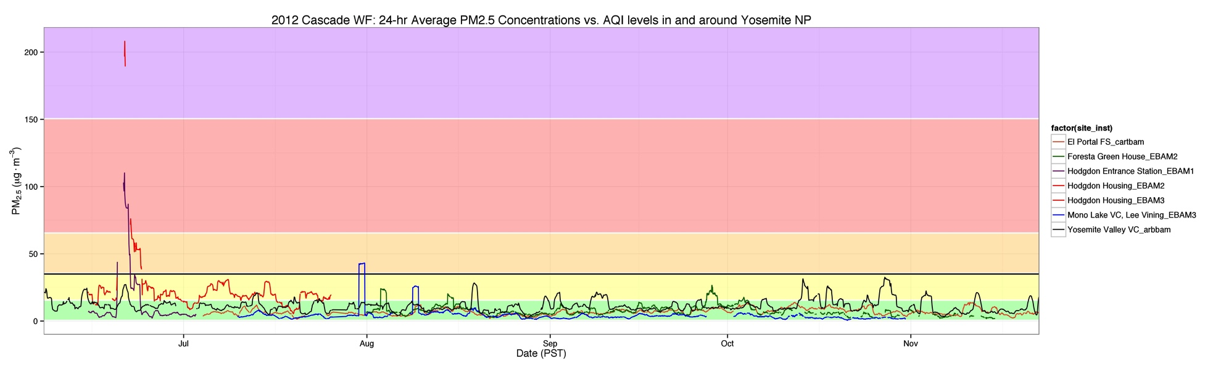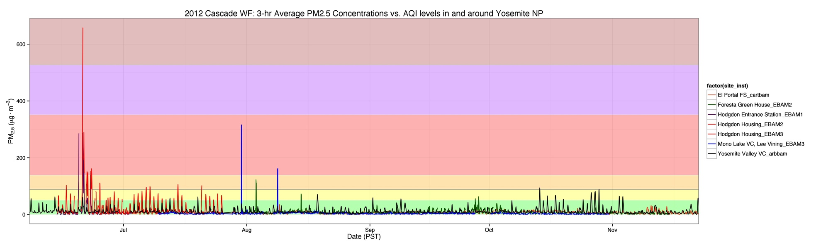

Cascade local influence
Cascade local influence Donna Savattere
Cascade local influence Donna Savattere
Cascade fire out, Mid-Nov

Robber’s Fire

Graham Fire
Indian Fire
Hodgdon Rx local Influence

*See Guidelines for Public Health Officials: http://www.arb.ca.gov/carpa/toolkit/data-to-mes/wildfire-smoke-guide.pdf
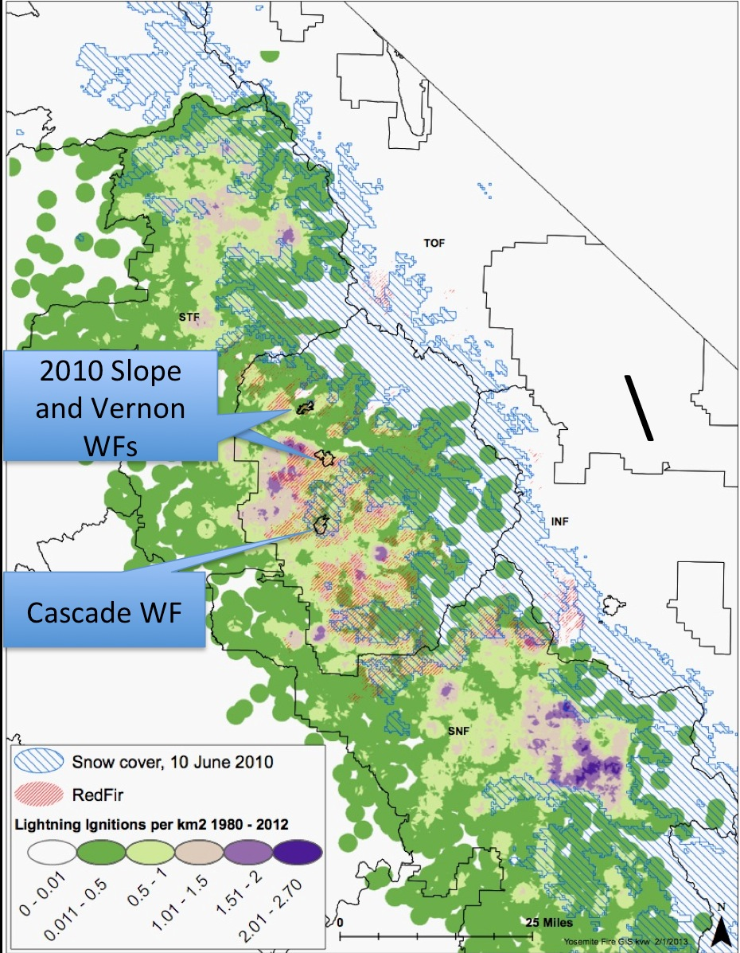
Figure 10. Ecological context: snow persistence, fire, and lightning in the high country. The Cascade fire was a rare fire, because of its location, the year in which it occurred, and the size to which it grew. Red fir forests are a good spatial proxy for finding areas like those where the Cascade WF was ignited, because they are characterized by persistent late season snow and less frequent lightning ignition. Fires that grow to sizes over 1000 acres are rare in these areas because of this late season wetness, usually only occurring in drought years like 2012. Our experience has been that the only way for fires in such areas to grow fast enough to impact air quality is for both the dry and unusually windy conditions to occur at the same time. Areas with these slow fire growth characteristics, where fires like the Cascade are likely to recur, are mapped below. Fires like the 2010 Slope and Vernon wildfires (also mapped), which moved into this same fuel type/elevation zone from lower elevations with higher lightning ignition frequencies, can also exhibit these slow growing characteristics.

Figure 11. Regional Climate Context. Graph below depicts departure from the 1949-2005 mean for overall Sierra Nevada summer temperature and precipitation, comparing 2012 to previous years. Note that in after a brief 2-3 year respite of “normal” to cool conditions, in 2012 we returned to a warmer regime where both the min and max summer average were well above the 1949-2005 climatology. Title 17 was enacted in 2002. These warmer than average temps allowed fuels in the upper elevation to become available to fire (e.g., the Cascade Fire). From a fire and smoke management perspective we would expect the most desirable, slow growing fires to occur in the upper elevations (e.g., red fir, Figure 10) during warm (pink) years. Conversely, large, slow growing fires in the mixed conifer (e.g., the 2011 Avalanche Fire or the 2010 Grouse Fire), would more likely occur in cooler (blue) years. Cool (blue) years therefore are times to takes advantage of slower fire growth (and lower daily emissions) that protect air quality, especially in the mixed conifer, so that key areas of the landscape don’t burn more severely and with greater AQ impacts in hotter years. Several studies, at both the state and regional level show that if current climate trends continue, we can expect more of these warmer years than cooler years, with more area burned, higher burn severity, and greater daily emissions as a result (Miller et al., 2009, Westerling and Bryant, 2011).

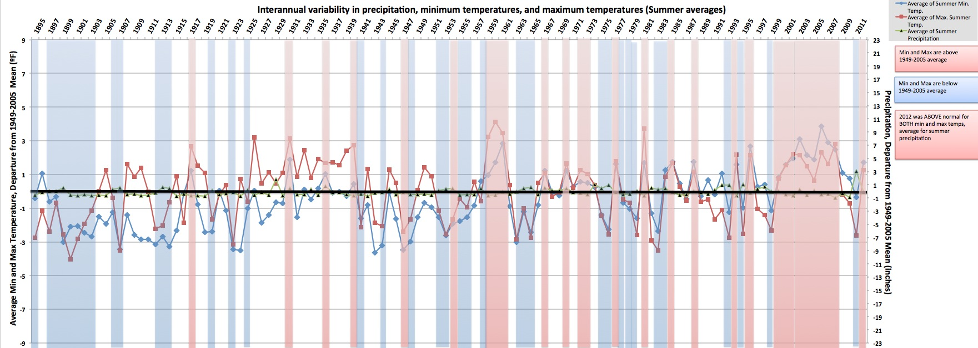
Warm/pink years = more favorable to high elevation fires (e.g, Cascade)
Cool/blue years = more favorable to lower elevation fires (e.g., mixed conifer)

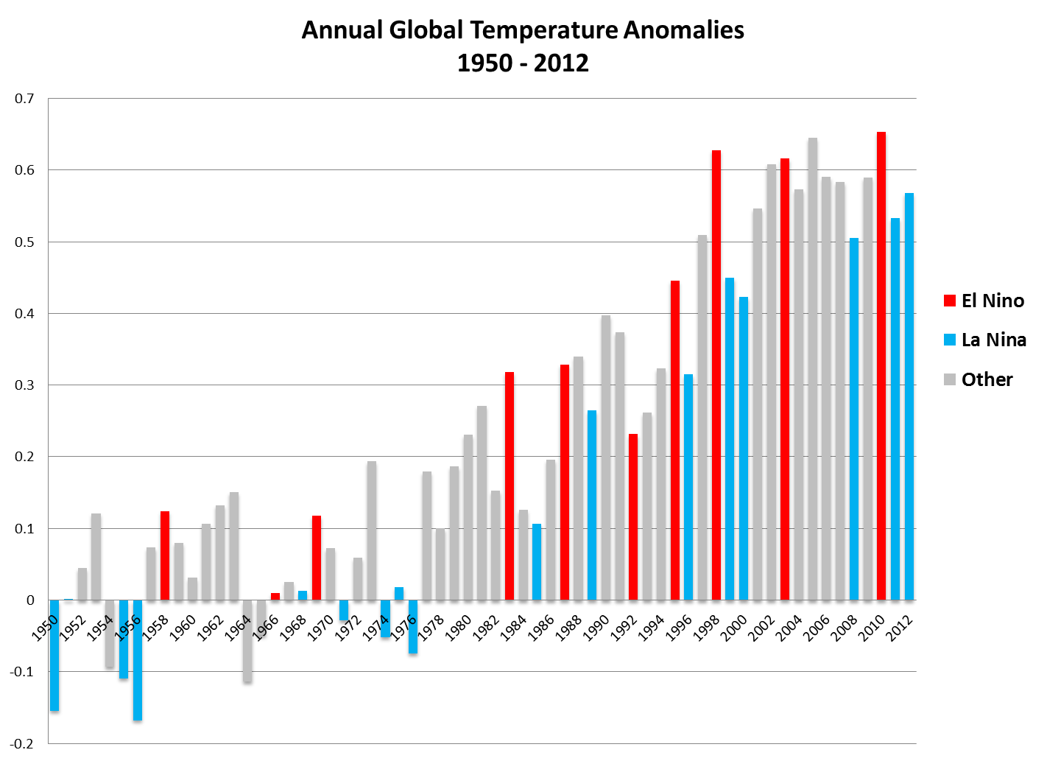
Figure 12. Global climate context. On a global scale, 2010 and 2011’s relatively cool temps were a temporal and spatial anomaly. This year, 2012, was the 36th consecutive year that global temperatures were above average. Currently, the warmest year on record is 2010, which was 0.66°C (1.19°F) above average. Including 2012, all 12 years to date in the 21st century (2001–2012) rank among the 14 warmest in the 133-year period of record. Only one year during the 20th century—1998—was warmer than 2012. The global annual temperature has increased at an average rate of 0.06°C (0.11°F) per decade since 1880 and at an average rate of 0.16°C (0.28°F) per decade since 1970. Most of the rest of the world, especially the high latitudes and including Yosemite, experienced hotter-than-average temperature in 2012, which was, averaged over the whole globe, the 10th warmest on record (NOAA, 2012, http://www.ncdc.noaa.gov/sotc/global/).
